2013 Great Plains Tree Pest Council Meeting

Agenda (2.5 days)

Hosted at: Radisson Hotel, Downtown Fargo
201 5th St North Fargo, ND 58102
(701) 232-7363

Monday July 8th (5:30): Informal meeting on rooftop of Hotel Donaldson tall grass prairie area (weather permitting). In case of rain, we will meet in the lounge/bar on the ground level.

Tuesday July 9, 2012

7:00 – 8:00 AM Breakfast and Coffee, provided

8:15 – 8:30 AM Welcome & introductory remarks

8:30 – 9:15 AM Speaker: Dr. Jared LeBoldus, Flooding effects on trees in the Missouri River Basin in ND

9:15 – 9:45 AM Speaker: Dr. William Jacobi, Colorado State University: National Elm Trials

9:45 – 10:00 AM BREAK: Begin Tree Disorders of the Northern Plains Quiz

10:00 – 10:45 AM Speaker: Dr. Joe Zeleznik: A history of trees in the Northern Plains through tree ring analysis

10:45 – 11:30 AM Speaker: Dr. Gerald Fauske, NDSU Entomology: Exotic bark beetle trapping: new findings

11:30 – 12:00 PM Diseases of Trees in the Great Plains: Project Update

LUNCH BREAK Lunch Provided: Common Tree Disorders of the Northern Plains Quiz/View Displays

1:00 – 1:45 PM Speaker: Dr. John Ball, South Dakota State University, Windbreak Health

1:45 – 3:00 PM State Reports Begin (approx. 30 minutes per person, per state – including discussion)

3:00 – 3:15 PM BREAK: Complete Common Tree Disorders of the Northern Plains Quiz

3:15 – 5:00 PM Fargo Forestry Elm Management Tour

5:00 – Dinner together / on your own

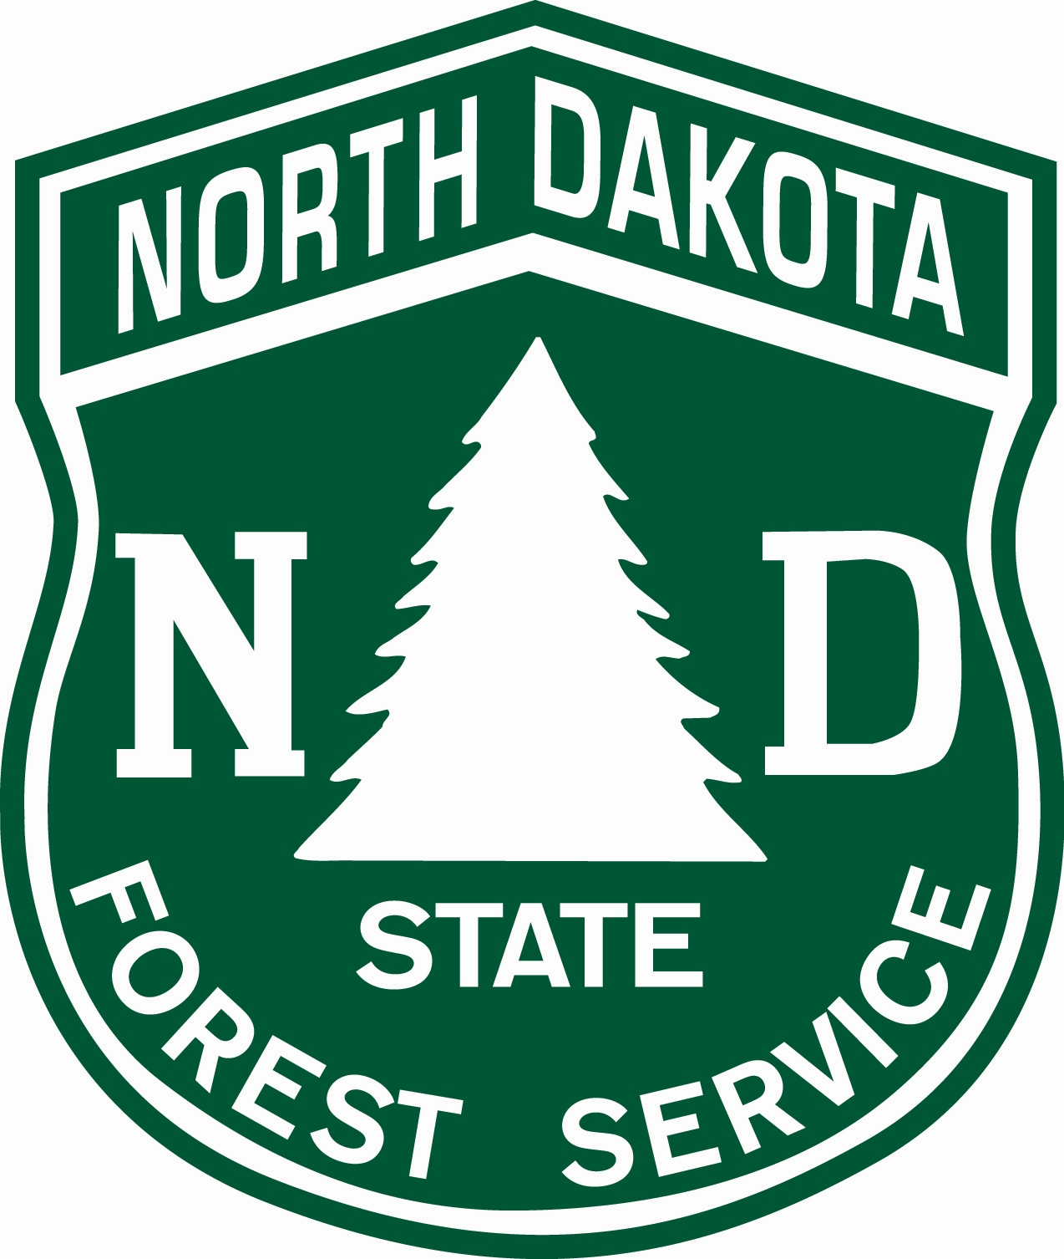

2013 Great Plains Tree Pest Council Meeting

Wednesday July 10, 2012

7:00 – 8:00 AM Breakfast and Coffee Provided

8:15 – 9:00 AM Opening Remarks, State Reports

9:00 – 9:15 AM General Membership Business Meeting: Changing of the Guard, Nominations/Election for board member positions

9:15 – 9:30 BREAK: Common Tree Disorders of the Northern Plains Quiz: Award Ceremony

9:30 – NOON State Reports

LUNCH Lunch Provided (Pick Up Box Lunch Before Departure)

NOON – 4:30 PM Absaraka Horticultural Research Farm and Tree Selections for the Northern Plains

Stop for group photo at famous wood chipper from the 1996 movie “Fargo” ***

5:00 – Dinner together / on your own

***Joke courtesy of Jim Walla

2013 Great Plains Tree Pest Council Meeting

Thursday July 11, 2012

7:00 – 8:15 AM Breakfast and Coffee, provided

8:15 – 12:00 PM Discussion/working groups: Update of Diseases of Trees in the Great Plains Book

Topics to be discussed include:

Authorship: Crediting work of updates and former authors, format

Foreword, Intro, Glossary, etc.: Topics, issues and who authors?

Consolidated chapters/Chapters without authors: Authorship, concerns?

Content: Outstanding needs, suggested authorship?

Photos: Image needs

Timeline: Looking ahead

*There may be time to work/collaborate following discussions

LUNCH BREAK Lunch on your own

Adjourn

Hotel Information:

Radisson Hotel, Downtown Fargo
201 5th St North Fargo, ND 58102
(701) 232-7363
http://www.radisson.com/fargo-hotel-nd-58102/fargo
Check in on Monday the 8th and check out the 11th for those that decide to stay later.
Currently 40 rooms are being held - more can be added if needed.
Please make your reservations before the 10th of June.
Hotel Services
- Airport shuttle (complimentary)
- ATM
- Business Center with fax and copy services
- Conference center with 10,000 square feet of meeting and banquet space
- Fitness Center with treadmill, exercise bike, elliptical and free weights
- Full-service restaurant and lounge
- High-speed, wireless Internet access (complimentary)
- Hotel pickup for FedEx and UPS (drop off at front desk)
- Same-day valet dry cleaning (Mon-Fri)
- 3$/day parking in attached garage

