Dear County-Paid Extension Staff Member:

The NDSU Employee ID Request form available in the Human Resources/Payroll – Employment section at www.ndsu.edu/forms/ is used to generate a temporary employee ID that you will need in order to request NDSU email service. This form is also used to create access for you to take NDSU and NDUS online trainings. Please complete the form following the instructions below, sign it, then fax it to Human Resources/Payroll at (701) 231-9686. Contact the NDSU Help Desk to help walk you through the process of setting up your NDSU email.

In the section below, please complete everything but your social security number. Cell phone number is optional.

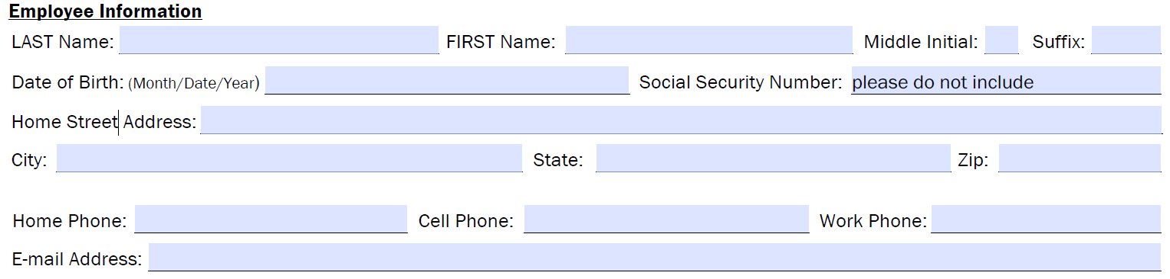

Enter only the Dept Name and # as shown below and your Start Date:

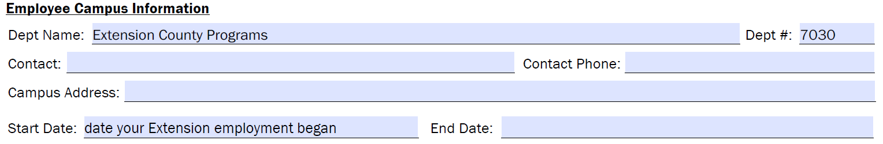

In the next section, please check the boxes as they are marked, enter your county name and hand-write “County Employee” as shown:

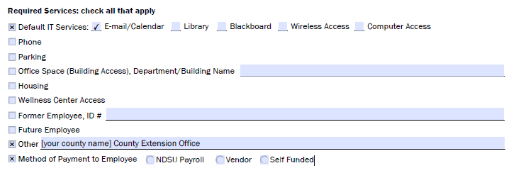
County Employee

Finally, enter your supervising agent email address and phone as shown, have him/her sign and date on the “Reports to” line, then you, as employee sign and date.

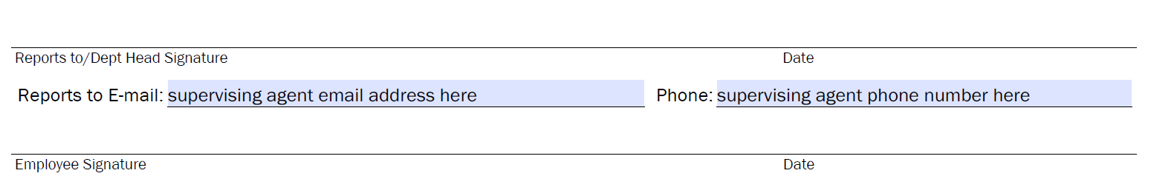

An important note: In February and September of each year NDSU goes through a 'purging' process of some email accounts (those belonging to students no longer here and those with temporary employee IDs). An email goes out from NDSU.HelpDesk@ndsu.edu that may show “HECN South Maintenance” as the subject, and “Our records show that you are no longer taking classes…” as the message.

In an effort to streamline this ‘purging’ process, I have created and maintain a list that contains the names of Extension staff members who are paid by their county. If all goes right, my providing this list to NDSU ITS will prevent you from ever being bothered with the purging email. In case I miss someone on the list, however, if you receive an email like the one described above, please reply to it right away so your email service is not terminated. Simply type "I am currently working in the [insert county name)] County Extension Office. Please do not remove my account." Also let me know that you received the email so I may update my list.

If you have any questions about this, please contact me.

Thanks,

Jon Fry and Jerry Ranum
Agriculture Communication IT System Specialists
NDSU.AGTECH@ndsu.edu

1.14.2019

