FOR IMMEDIATE NEWS RELEASE

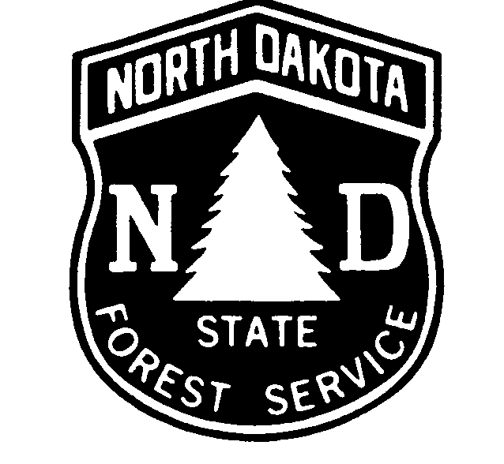
November 7, 2018

NDSU-NORTH DAKOTA FOREST SERVICE
307 1st Street East
Bottineau ND 58318-1100

Contact: Derek Lowstuter, Forest Stewardship Manager
North Dakota Forest Service at (701) 328-9990

CHRISTMAS IS A TIME TO GET REAL…
A REAL TREE!

Bottineau – A real Christmas tree, with all its green color and smell, appeals to people because it’s bringing something alive indoors. While they are growing outdoors, real Christmas trees stabilize soil, protect and clean water, sequester carbon, provide wildlife habitat, and give off fresh oxygen while creating some beautiful scenery on Christmas tree farms. Real trees can also be reused and recycled after the holidays for mulch and wildlife habitat, check with your local department of public works for information.
A real tree is fresh when the needles are green and flexible and don't come off readily when you pull the branches through your fingers or bounce the tree on the ground. An early visit to a local “retail lot” or "choose and cut" tree farm will ensure the freshest and fullest tree possible.
To keep it fresh, store your tree in a cool garage or shaded place after purchase until you are ready to bring it indoors. Keeping the tree in an unheated, but well-protected, space like a garage will also acclimate the tree to the warmer indoor temperature and help retain needles. Keep your tree away from major sources of heat (fireplaces, heaters, heat vents, direct sunlight). Cut at least a half inch off the bottom trunk base before putting it in water, and keep the tree stand container full of water until you discard the tree. Real trees also provide something that artificial trees can’t…a holiday fragrance and feeling.
For more information on real Christmas trees, contact: Derek Lowstuter
North Dakota Forest Service
(701) 328-9990.

