Who is Eligible?  The Forest Stewardship Program offers management advice to landowners for maintaining and improving forestlands and windbreaks. The program provides a management plan free of charge.  For more information, contact:  Walhalla Field Office  101 5th Street  Walhalla, ND 58282  (701) 549-2441  Jamestown Field Office 300 2nd Ave. NE, Suite 208A  Jamestown, ND 58401  (701) 400-8330  Lisbon Field Office  6824 Hwy 32 S - PO Box 604 Lisbon, ND 58054 (701) 683-4323  Bottineau Field Office  1037 Forestry Drive  Bottineau, ND 58318  (701) 228-3700  Bottineau Headquarters  307 Forestry Drive  Bottineau, ND 58318  (701) 228-5422  Bismarck Field Office  916 E. Interstate Ave #4  Bismarck, ND 58503  (701) 328-9944  Towner State Nursery  878 Nursery Road  Towner, ND 58788  (701) 537-5636  www.ndsu.edu/ndfs |  | The mission of the NDSU-North Dakota Forest Service is to care for, protect and improve forest and natural resources to enhance the quality of life for present and future generations.  Participation in the Forest Stewardship Program is strictly voluntary and open to any non-industrial private forest landowner.  North Dakota State University does not discriminate on the basis of age, color, disability, gender expression/identity, genetic information, marital status, national origin, public assistance status, race, religion, sex, sexual orientation, or status as a U.S. veteran. Direct inquiries to the Vice President for Equity, Diversity and Global Outreach, 205 Old Main, (701) 231-7708.  This publication is available in alternative formats upon request by calling (701) 228-5422. | 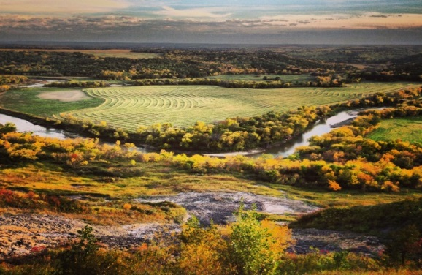 | Forest Stewardship Program  - North Dakota  - Forest Service
10/13

Helping Private Landowners Manage Their Forest Resources  Approximately 45 percent of all forestland in the United States, about 354 million acres, is owned by non-industrial, private forest landowners and are predominantly “family forests.” In North Dakota, approximately 70 percent of forestland is privately owned. These privately owned forests are critical to sustaining America's clean water and air, wildlife habitat, recreational opportunities and wood products. The Forest Stewardship Program (FSP) provides technical assistance to non-industrial private forest landowners to encourage and enable active, long-term forest management.  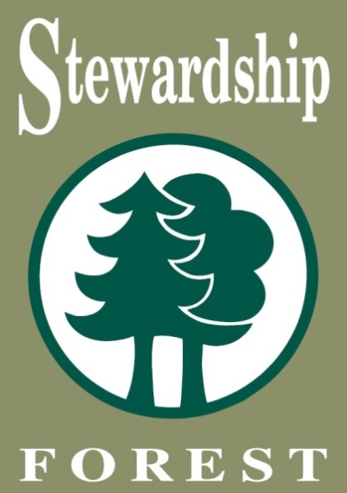 |  | 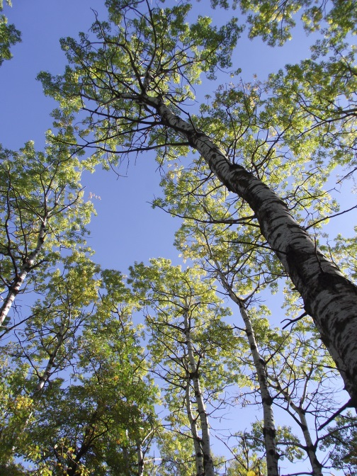  Benefits to Landowners  - On-site professional forestry technical assistance.  - Inventory of your forest, including forest health, management, and long-term conservation.  - Access to financial assistance programs and tax benefits.  - Receive a written Forest Stewardship Plan specialized for your property. | 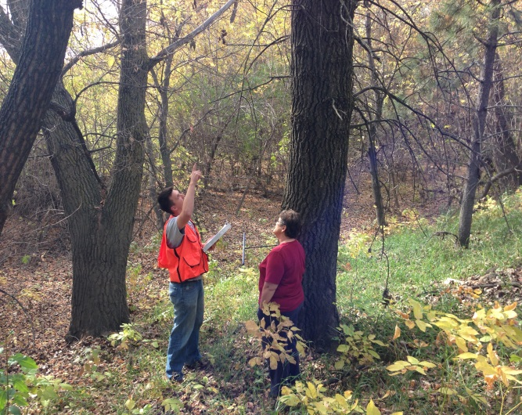 | The Process of Developing a Forest Stewardship Plan  - Contact the nearest ND Forest Service office.  - Meet with the forester to discuss your goals and objectives.  - The forester will survey your forest.  - You will receive a Forest Stewardship Plan at no charge.

