N O R T H D A K O T A F O R E S T S E R V I C E

2020 TREES AWARDS CATEGORIES

The TREES AWARDS recognize individuals, organizations and agencies who contribute in an outstanding way to forestry activities. Forestry activities can include: fire mitigation, protection and suppression; tree planting, preservation, or maintenance; community forestry efforts; forest management practices; forest recreation; or environmental education.

Base your nomination on the following categories:

COMMUNITY OF THE YEAR
A community that demonstrates, through exemplary leadership or outstanding example, its commitment to the development or enthusiastic continuation of a sustainable community forestry program for present and future generations.

CONSERVATION ACHIEVEMENT
An individual, family or business that exhibits an outstanding commitment to overall conservation including the planting and care of trees and shrubs for the purpose of enhancing North Dakota's landscape.

DISTINGUISHED SERVICE AWARD
Presented to an individual exhibiting enthusiastic promotion of forestry principles and practices including: fire mitigation, protection and suppression; tree planting, preservation, or maintenance; community forestry efforts; forest management practices; forest recreation; or environmental education.

EXCELLENCE IN GOVERNMENT
An agency or division of government at any level that exhibits extraordinary effort and dedication in the conduct of programs and projects that result in a significant benefit to forestry.

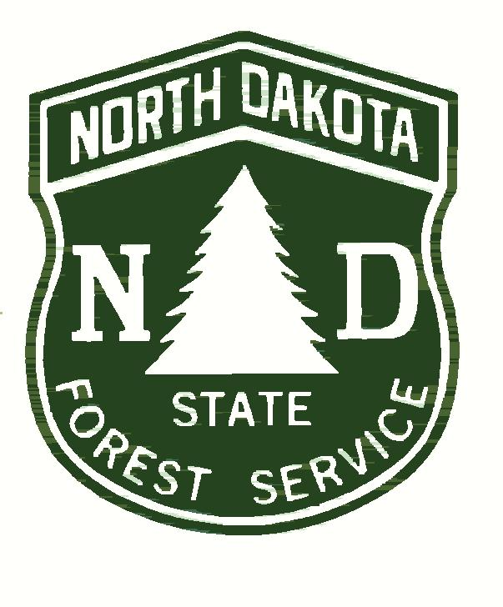
MEDIA OUTREACH
An individual or company that disseminates news, editorial, commentary, documentary or other information which assists in raising public awareness about the benefits and challenges associated with forestry activities.

NATURAL RESOURCES PROFESSIONAL
An individual employed in the natural resources field dedicated to forestry, fire, stewardship, tree planting, tree care or tree preservation through exemplary leadership or outstanding example at the local, county, regional or state level.

TREE CELEBRATION
A celebration which highlights the many benefits that trees provide and incorporates both an educational component and hands-on activity to stimulate increased knowledge, interest and action.

VOLUNTEER ORGANIZATION
An organization that exhibits the true spirit of leadership, dedication and volunteerism by planning, conducting and maintaining outstanding forestry projects.

YOUTH TREE PLANTERS
A youth group whose members exhibit genuine concern for the natural environment by participation in tree planting, tree care, tree preservation or tree knowledge projects and activities.

2020 TREES AWARDS

NOMINATION FORM

Please complete the following information for each nomination submitted. Award categories are listed on the back side of this sheet. Duplicate this form as often as you like and please type or print clearly. Additional sheets or exhibits may be helpful. Please be sure to include photos or slides of the nominee(s) and projects that the nominee has been involved in.

AWARD CATEGORY:________________________________________________________________________

NOMINEE'S NAME:__________________________________________________________________________

TITLE OR POSITION:___________________________ ORGANIZATION:_____________________________

MAILING ADDRESS:__________________________________________________________________________

CITY/STATE/ZIP:_____________________________________________________________________________

PHONE NUMBER: Office:______________________________ Home:_________________________________

NARRATIVE EXPLANATION of what the nominee has accomplished that prompts your nomination.

_____________________________________________________________________________________________

_____________________________________________________________________________________________

_____________________________________________________________________________________________

_____________________________________________________________________________________________

_____________________________________________________________________________________________

_____________________________________________________________________________________________

_____________________________________________________________________________________________

* * * * * * *

NOMINATOR'S NAME:_______________________________________________________________________

MAILING ADDRESS:__________________________________________________________________________

CITY/STATE ZIP:_____________________________________________________________________________

PHONE NUMBER: Office:___________________________ Home:____________________________________

SEND FORM BY AUGUST 1, 2020, TO: Trees Awards Nomination
NORTH DAKOTA FOREST SERVICE
916 East Interstate Avenue, Suite 4
Bismarck, ND 58503

OR via email at aubrey.davis@ndsu.edu

Please be sure to include photos of the nominee(s) and projects that the nominee has been involved in!

