NDSU Extension Service Presents:

Introduction to 3D Printing

Thursday, February 27th 4:30PM

Burleigh County Building
3715 E Bismarck Expressway, Bismarck, ND

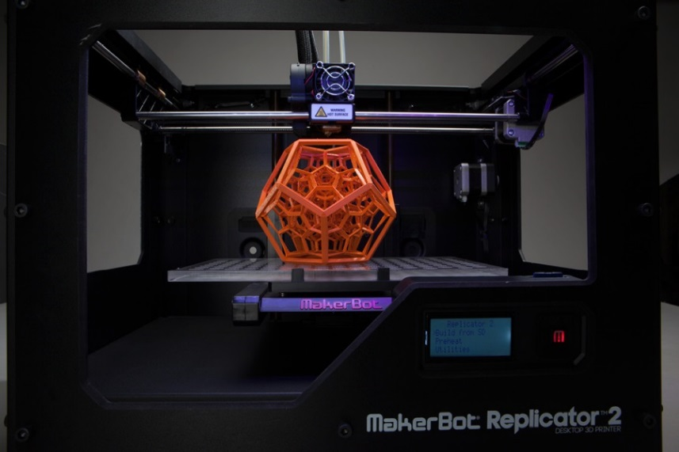

Come learn how this new disruptive technology works and how you can use it! 3D printing allows you to quickly and inexpensively design and create virtually anything imaginable.

NDSU Computer Services Specialist Ben Bernard will demonstrate how to 3D print using the MakerBot Replicator 2 and how 3D printing empowers educators, students, entrepreneurs, and home owners. Bernard has successfully consulted on grants funding 3D printing and is responsible for the NDSU Architecture & Landscape Architecture 3D printing lab.

Jake Clark, owner of Fargo 3D Printing and lead designer at Alderon Industries, will share how 3D printing is used to enhance manufacturing processes and quickly bring new products to market. With a strong background in manufacturing, Clark knows how 3D printing fits in with the workflow of engineers, designers, and inventors.

David Lehman, NDSU’s Industrial and Manufacturing Engineering Extension Specialist will share his views on how 3D printing and additive manufacturing will shape the future of manufacturing.

Many printed products and objects will be on display. Bernard, Clark, and Dave will answer questions about this revolutionary technology and reveal how 3D printing can be used to create ‘makerspaces’; bringing students, creative enthusiasts, and professionals together to do extraordinary things!

This event is free and open to the public. For more information or to register contact:

David Lehman
NDSU Industrial and Manufacturing Engineering
Extension Specialist
701.730.3956
david.lehman@ndsu.edu

Additional information regarding the NDSU Industrial and Manufacturing Engineering Extension program can be found on the website at www.ag.ndsu.edu/manufacturing or via facebook at www.facebook.com/ndsumanufacturing.

