DETERMINING THE ECONOMIC RESPONSE OF SODIC SOILS TO REMEDIATION BY GYPSUM, ELEMENTAL SULFUR AND VERSALIME IN NORTHEAST NORTH DAKOTA ON TILED FIELDS
By
Naeem Kalwar (Extension Area Specialist/Soil Health)

- INTRODUCTION:
Soil salinity and sodicity are two major soil health issues facing North Dakota producers throughout the State. Brennan J., and M. Ulmer reported 5.8 million saline acres in North Dakota (Salinity in the Northern Great Plains, Natural Resources Conservation Service, Bismarck, N.D. 2010). Some studies even suggest about 90% of the soils are affected by high salt and sodium levels. Reported history of North Dakota soils with high levels of soluble salts and sodium goes back to 1960s. NDSU Extension Bulletin No. 2 reported more than 1 million acres affected by high salt levels, whereas, more than 2 million acres were to have excessive levels of sodium (Salt Affected Problem Soils in North Dakota, Their Properties and Management by Gordon A. Johnsgard, reprinted in 1974). That is a result of high salt and sodium levels in the soil parent material and the underlying sodium-rich shale (present in the bedrock below the soil sediments). Rising water-table levels and resulting capillary rise of soil water then leads to the accumulation of excessive salts and sodium within the plant root zone or at the soil surface.

With more acres affected each year, the management and alleviation of saline and sodic soils cannot be stressed enough.

Saline soils will have excessive soluble salts in the soil solution high enough to limit the ability of plant roots to absorb soil water even under wet conditions, causing drought like symptoms (“osmotic effect”).

Salts, however, result in higher amounts of positively charged ions like calcium (Ca⁺⁺) and magnesium (Mg⁺⁺) that promote flocculation (opposite of dispersion) by moving in close to the negatively charged particles, thereby reducing their tendency to disintegrate or disperse from each other (The Nature and Properties of Soils, Nyle C. Brady and Ray R. Weil, 14th Edition, Revised). Flocculation of soil particles keeps soil structure in good physical condition resulting in better soil porosity and creating conditions conducive for improved soil water infiltration and drainage. Being mobile in soil water, soluble salts can be leached out of the plant root zone by lowering the water-table level.

In contrast to saline soils, sodic soils have excessive levels of sodium ions (Na⁺) adsorbed at the soil cation exchange sites. Soil sodicity causes degradation of soil structure. That process is called “soil dispersion”.

Soil sodicity is an excessive Na⁺ issue and not an excessive salt problem. A typical salt will be a combination of a positively charged ion attracted to a negatively charged ion (for example Na⁺Cl⁻). In sodic soils, excessive Na⁺ is attracted to the negative charges of soil particles, mainly clay. Forces that hold clay particles together are greatly weakened when excessive Na⁺ is adsorbed at the negative charges of soil clay particles, forming Na⁺-clay particles (Seelig, 2000). When wet, Na⁺-clay particles get easily disintegrated or dispersed from the larger soil aggregates. Also, due to the larger hydrated size of Na⁺ ions, Na⁺-clay particles clog the soil pores (especially macro-pores) and settle down in dense layers (The Nature and Properties of Soils, 14th Edition, revised).

Poor physical structure then results in soils difficult to till, poor seed germination and restricted plant root growth. Due to the poor structure, sodic soils are also susceptible to wind and water erosion compared to saline soils. Soil dispersion effect will be more severe on expanding-type of clays as their degree of swelling increases, causing further shrinking of the larger soil pores. Once that happens, it severely impedes the soil drainage thus making it even more difficult to manage than soil salinity.

Remediation of soil sodicity requires an extra step of applying amendments that supply Ca⁺⁺ directly or indirectly followed by salinity remediation practices of improving soil drainage and lowering the water-table level. Ca⁺⁺ displaces Na⁺ from the cation exchange sites and Na⁺ moves into soil solution where it converts into a salt (Na₂SO₄) and leaches out. Common soil amendments include gypsum, elemental sulfur, sulfuric acid, calcium chloride, calcium nitrate and calcium carbonate or lime (for acidic soils).

- PURPOSE:

Salts and sodium can only be leached downward into the soils with rainfall or irrigation. That will require lowering the water-table level. One way is to install a subsurface drainage system like tile drainage which is gaining popularity due to the ongoing wet-weather cycle.

Basic purpose of a drainage system is to drain the excess soil water out of the plant root zone as quickly as possible depending upon the soil type. In order to achieve that objective, soils should be analyzed for soluble salts (Electrical Conductivity) and sodium (Sodium Adsorption Ratio or Exchangeable Sodium Percentage) levels prior to tiling. Generally tiling companies analyze soils for textural analysis in order to determine the tile size, depth and spacing between them. Analyzing soils for sodium is especially important as it can lead to the sealing of soil layers above or around the tiles, thus making the drainage system ineffective. Soils high for salts and sodium may not initially show the dispersion effects as salts will counter the dispersive nature of sodium, however, once a tile drainage system is in place, it may lead to the leaching of soluble salts, making the sodium problem worse.

The Depth of sampling should also exceed the deepest depth of the tiles in one foot increments. For detailed information please refer to the NDSU Publication: SF-1617; “Evaluation of Soils for Suitability for Tile Drainage Performance”. Question for producers considering tiling could be:

Can they successfully improve soil drainage by tiling their sodic or saline-sodic soils before remediating sodicity?

The Langdon REC has a saline-sodic site well suited for the research of this question and other soil and water management issues. In order to replicate field conditions, it was decided to tile the project site prior to starting sodicity remediation by applying soil amendments that are easily available to northeast North Dakota growers. After several meetings between NDSU Ag. Engineers, tile drainage design engineer, tiling company, local extension agents and Langdon REC staff, project layout was finalized to achieve research and extension objectives. Area growers quickly endorsed and supported this project and within a six month period over $80,000 was donated for the project. Installation of the tiles began on July 17th, 2014.

Layout includes dedicated plots for research trials and extension demonstrations. Research area includes four treatments (plots) in each replication with three replications. Treatment size is 325’ x 80’. Each treatment has four, 4” laterals, placed 4’ deep along with a water control structure. To minimize the subsoil flow from the neighboring treatments, each treatment was surrounded by a 10-12 mm thick, 5’ deep plastic barrier. Extension area includes 4 plots of 150’ x 150’. Each plots has four, 4” laterals, placed 3.5’ deep with a water control structure. Below is the detailed layout of the project site.

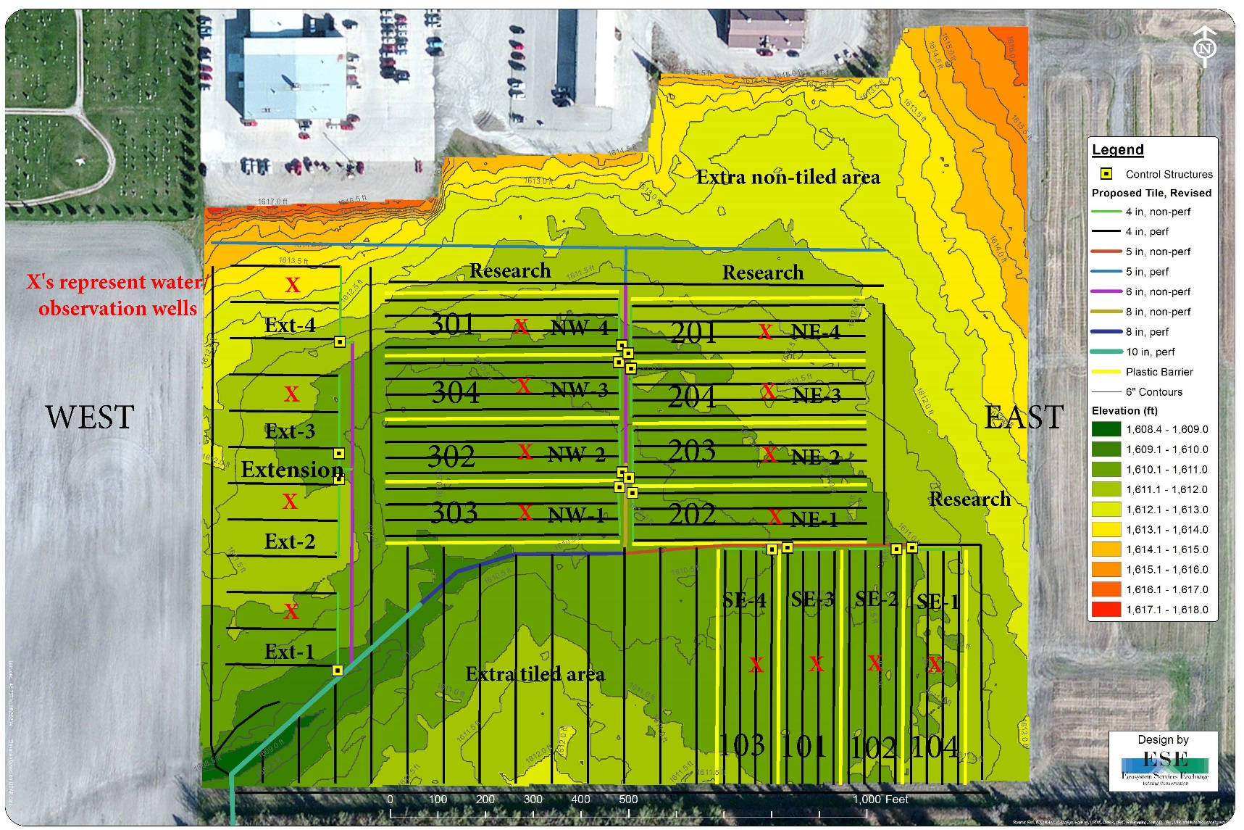

- REMEDIAL OBJECTIVES:

- First objective is to find out whether tiling can be successful on sodic or saline-sodic soils prior to sodicity remediation.
- Second objective is to compare the relationship between varying water table levels and resulting soil salt and sodium levels.
- Third objective is to analyze water samples from lift station, upstream and downstream for human and livestock health.

- SITE DESCRIPTION AND HISTORY:

As per web soil survey, The Langdon REC groundwater management project site is comprised of Cavour-Cresbard and Hamerly-Cresbard loams.

The Cavour series consists of very deep, moderately well and well drained soils formed in glacial till on uplands. Permeability is slow to very slow. Slopes range from 0 to 6%. Taxonomic class is fine, Smectitic, frigid Calcic Natrudolls. Depth to carbonates ranges from 14” to 35”. Depth to accumulation of gypsum and other salts ranges from 16” to 45”. Thickness of the Mollic epipedon typically is over 16” but ranges from 7” to 35”. The Natric horizon has an estimated sodium adsorption ration (SAR) or exchangeable sodium percentage (ESP) of 10 to 20.

The Cresbard series consists of very deep, moderately well and well drained soils formed in glacial till or local alluvium over glacial till on lower back slopes, foot slopes in depressions, and flats on uplands. Permeability is slow to moderately slow. Slopes range from 0 to 6%. Taxonomic class is fine, Smectitic, frigid Glossic Natrudolls. Depth to carbonate ranges from 15” to 40”. ESP exceeds 15 in the lower part of the B or in the C horizon. The particle size control section contains more than 15% fine or coarser sand.

The Hamerly series consists of very deep, somewhat poorly drained soils that formed in calcareous loamy till. Permeability is moderate in the upper horizons and moderate to moderately slow in the lower horizons. Taxonomic class is fine-loamy, mixed, superactive, frigid Aeric Calciaquolls. These soils are on flat or lake plains and on convex slopes surrounding shallow depressions and on slight rises on till plains. They have slopes ranging from 0 to 3%. The Mollic epipedon ranges from 7” to 18” in thickness. The top of the Calcic horizon is at depths of less than 16”, and in some pedons the lower part of the Mollic epipedon qualifies as part of the Calcic horizon. The soil contains 1 to 10% by volume of rock fragments. The 10” to 40” particle size control section has visible gypsum in some pedons. It has 18 to 35% noncarbonate clay. Saline and stony phases are recognized.

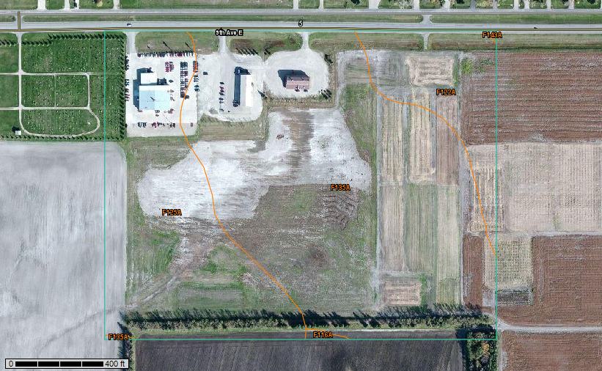
Cavour-Cresbard loams
Hamerly-Cresbard loams

- METHODOLOGY:

Soil Chemical Analysis

Four feet deep soil samples in 12” increments from each treatment were collected in September 2014. For each sample, 2 to 3 cores were taken from the middle of tiles. Samples were analyzed for the following chemical properties.

- 0-12”: N, P, K, O.M., SO₄, Cl, CCE, CEC, Ca, Mg, Na, saturated paste package (EC, SAR, pH, Saturation %), alkalinity (CO₃ and HCO₃) and particle size fractions.
- 12-24”: all of the above tests, excluding CEC.
- 24-36”: all of the above tests, excluding P, O.M. and CEC.
- 36-48”: all of the above tests, excluding P, O.M. and CEC.

Soil Physical Analysis:

In June 2015, 18” deep soil compaction measurements in 1” increment were taken with penetrometer. Gravimetric water content was measured for 12” depth in 6” increments and bulk density was measured for the top 10” in 5” increments. Penetrometer readings were taken through the Field Scout SC 900 meter, gravimetric water was measured by taking soil samples with standard soil auger and bulk density through undisturbed soil cores.

Weekly Water Table Level Measurements:

Water table levels were measured on a weekly basis from May-October along with EC and temperature through the observation wells in each plot with Solinst TLC 107 water level meter.

Water Sample Analysis:

Water samples were taken from lift station, upstream and downstream (100 to 200 feet from the pump station) in fall-2015 and were analyzed for the following.

- Group 2 complete mineral chemistry: bicarbonate, calcium, carbonate, conductivity, iron, magnesium, silica, nitrate, percent sodium, pH, potassium, sodium, sodium absorption ratio, hydroxide, total alkalinity, hardness, total hardness, total dissolved solids, turbidity, chloride, sulfate and fluoride.
- Group 7 trace metals: chromium, copper, zinc, arsenic, selenium, cadmium, barium, lead, manganese, iron, aluminum, boron, antimony, beryllium, nickel, silver, thallium and molybdenum.
  - Group 30 nutrients: ammonia, total phosphate, dissolved phosphorus, nitrate/nitrite and total nitrogen.

Note: Soil and water analysis will be done for four more years starting from 2016 by following the same protocols.

Calculation of Soil Amendment Rates:

Soil amendment rates were calculated to bring the SAR (SAR-final) numbers to an acceptable level of 3 in the 1st foot. That was done by deducting 3 from the actual SAR numbers (SAR-initial). In order to calculate soil amendments rates, SAR-final values were converted into ESP by using the following formula:
ESP = $\frac{(100\left(-0.0126+\left(0.01475*SAR\right)\right))}{(1+\left(-0.0126+\left(0.01475*SAR\right)\right))}$
(Diagnosis and Improvement of Saline and Alkali Soils, Agriculture Handbook No. 60, P-26 1954. United States Salinity Laboratory Staff).

Furthermore, ESP and cation exchange capacity (CEC) values of the 1st foot were used to calculate the milliequivalent of exchangeable Na/100 grams of soil by using this formula. That number was multiplied by 1.7 to get tons of 100 pure gypsum/acre feet:
$$Exchaneable Na Meq per 100 grams of soil=\frac{CEC*Ex.Na\%}{100}$$
(Diagnosis and Improvement of Saline and Alkali Soils, Agriculture Handbook No. 60, P-49 1954. United States Salinity Laboratory Staff).

For each ton of 100% pure gypsum, 0.19 ton of 100% pure elemental sulfur was applied (Reclaiming Saline, Sodic, and Saline-Sodic Soils. University of California, ANR Publication 8519, August 2015). Considering the very low solubility of Versalime, for each ton of 100% pure gypsum, 3 tons of VersaLime were applied.

The following formula was used to compensate for gypsum and elemental sulfur products that were less than 100% pure.
$$\frac{100}{purity\%}*tons equivalent to 1 ton of pure gypsum$$
(Reclaiming Sodic and Saline/Sodic Soils. Drought Tips Number 92-33, University of California Cooperative Extension, 1993).

Trial Location:

Trial site is located at the NDSU Langdon Research Extension Center, Langdon, North Dakota.

Design and Plot Size:

Trial design is randomized complete block. Each plot was 325 X 80 feet.

Treatments and Replications:

Following treatments were applied with a total of three replications.
- Control.
- Full rate of 99.5% pure gypsum to lower soil SAR-final levels to 3.
- Full rate of VersaLime to lower the soil SAR-final levels to 3.
- Full rate of 90% pure elemental sulfur (S°) to lower the soil SAR-final levels to 3.

Amendment Rates:

Treatment | 99.5% Gypsum | 90% Elemental Sulfur | VersaLime
number | tons/plot | tons/plot | tons/plot
101 | 0 | 0 | 0
102 | 4.47 | 0 | 0
103 | 0 | 0 | 8.74
104 | 0 | 2.10 | 0
201 | 0 | 0 | 0
202 | 7.25 | 0 | 0
203 | 0 | 0 | 30.45
204 | 0 | 0.61 | 0
301 | 0 | 0 | 0
302 | 10.67 | 0 | 0
303 | 0 | 0 | 22.93
304 | 0 | 2.16 | 0
Total | 22.40 | 4.87 | 62.14

Note: Gypsum and elemental sulfur were applied on June 29th, whereas, VersaLime was applied on July 23rd. All of the amendments were then rototilled into the soil. Control plots were also rototilled for replication purposes. Control structures for all of the treatment were fully opened in order to achieve maximum leaching conditions.

Grass Planting:

In order to establish a vegetative cover, an equal mix of Tall, Slender, Intermediate and Green wheatgrasses and Russian Wildrye were hand broadcasted and harrowed in on August 28th at the rate of 7 lb/acre.

