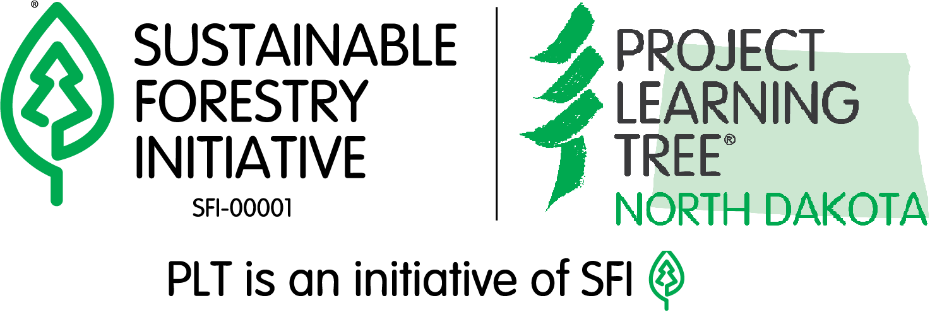**Explore Your Environment K-8 Guide**

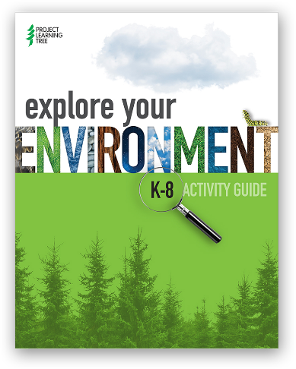PLT's new flagship *Explore Your Environment Guide*includes hands-on activities to connect children  
 to nature and increase young people’s awareness  
 and knowledge about their environment.

* 50 multidisciplinary activities grouped by grade
* Activities require few special supplies or extra preparation
* Correlated to national and state learning standards
* All activities include reproducible student pages, background information for educators, easy-to-follow instructions, and additional online resources

**Trees & Me (Ages 1-6)**

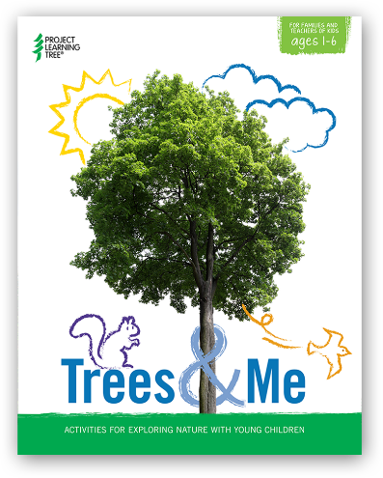Fun, easy-to-do, hands-on experiences to connect young children to nature, with a focus on trees and forests. Through both outdoor and indoor activities, children explore nature through their senses, experience trees throughout all four seasons, and connect with their community.

* Hands-On Learning Experience
* Social and Academic Skills Development
* Easy-to-Use Activities for Families and Teachers

**Green Jobs: Exploring Forest Careers (Ages 12-25)**

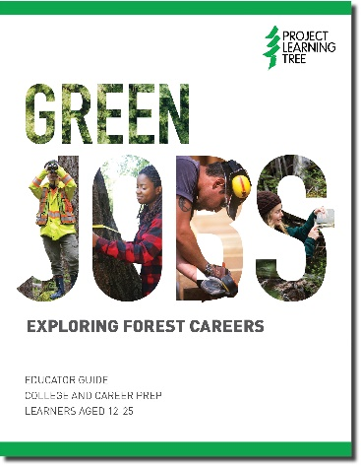Four hands-on, NGSS aligned, instructional activities to help youth research forestry jobs, and practice managing and monitoring forest resources. It is designed for educators, career and guidance counselors, Scouts, 4-H, and FFA leaders, foresters, and job training advisors to use to prepare learners for college and beyond.

**Activity Collections from   
Project Learning Tree**

These activity collections take activities in the K-8  
 *Exploring Your Environment* guide and groups them together by themes. The activities can be used as individual stand-alone lessons, or all together as a storyline or unit.

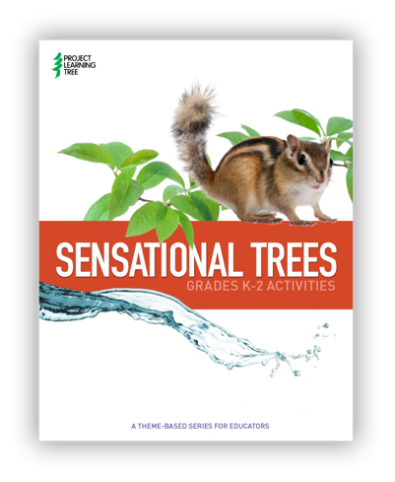

**Sensational Trees Activity Collection (K-2)**

Learners investigate trees using their senses.

Activities:

• The Closer You Look

• Peppermint Beetle

• Adopt a Tree

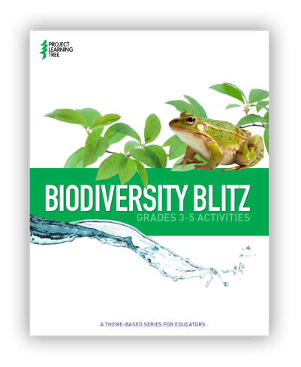

**Biodiversity Blitz Activity Collection (3-5)**

Learners investigate the variety of species in an ecosystem, and how this variety — or biodiversity — helps sustain life on Earth.

Activities:

* Discover Diversity
* Charting Biodiversity
* Web of Life

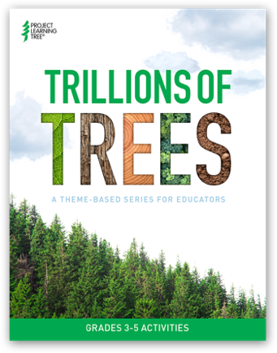**Trillions of Trees Activity Collection (3-5)**

Learners investigate the unique characteristics of different tree species and how best to plan, plant, and care for trees in their community.

Activities: 

• Tree ID

• Trees in Trouble

• Plant a Tree

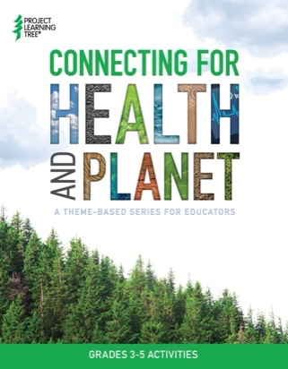**Connecting for Health and Planet Activity Collection (3-5)**

Learners investigate how being outside — and among trees, specifically — provides people with many different physical, emotional, social, and learning benefits.

Activities: 

* Get Outside!
* Poet-Tree
* Helping Hands

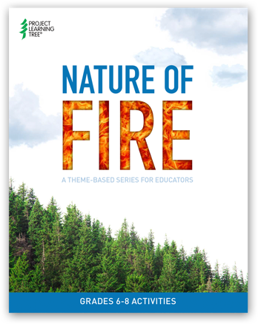**Nature of Fire Activity Collection (6-8)**

Students to investigate wildland fire and ecosystem change.

Activities:

• Nothing Succeeds like Succession

• Living with Fire

• Burning Issues*

*Burning Issues is an adaptation of The Global Climate, from *Explore Your Environment: K-8 Activity Guide*. While Part A remains the same, with students investigating atmospheric carbon dioxide levels of the past, present, and future, Part B is uniquely adapted to explore the ways in which CO2 levels in the atmosphere, global climate change, and wildfire are connected.

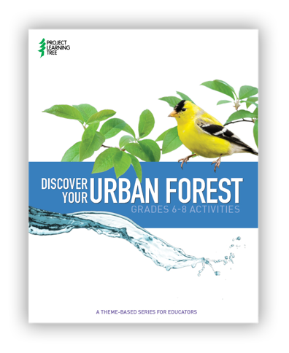

**Discover Your Urban Forest Activity Collection (6-8)**

Learners explore their urban environment and investigate environmental issues that affect their urban community.

Activities: 

* Decisions, Decisions
* Environmental Justice for All
* Forest in the City