**Cowherd Mineral Supplementation: Why, When, What, How**

John Dhuyvetter

Mineral content and availability from forages grown in the region varies with plant maturity and soils. Forage analysis often reflects levels below established requirements particularly for trace mineral levels of copper, zinc, cobalt, and iodine; and the major mineral needed phosphorous. Diminished health, reproduction, and production of the herd can be the consequences of mineral shortages; noticed as weaker calves, higher incidence of scours and respiratory disease, cows failing to clean after calving, slow breed back, a greater percentage opens, lighter weaning weights, lower cow condition, and greater lameness.

Green and growing forage is typically adequate for phosphorus and vitamins but may not meet animal requirements as it senesces. Magnesium and calcium can be low on early new growth, raising tetany concerns. Furthermore mineral needs are greater in late gestation during rapid fetal development, peak lactation, and for breeding. While minerals and vitamins are needed continuously year round, the potential need and likely shortage is greatest associated with the winter spring calving-breeding period and again late fall while grazing low quality forage and in preparation for weaning stress.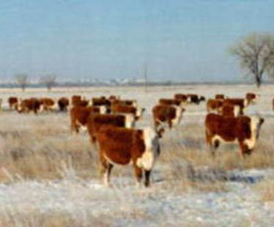

Along with block or loose salt, many good commercial mineral/vitamin supplements are on the market formulated to meet specific feeding situations and in some cases contain additives to enhance feed digestion or animal health. Of note is that harvested forages tend to high in calcium and can be marginal in phosphorous. Since animals need to receive a ratio of more calcium to phosphorous, many cow minerals are formulated as 1 to 1 Ca to Phos product plus trace minerals at a level appropriate for region at the recommended intake, essentially meeting the animal’s daily need (4oz per day with 1250 ppm Cu). Of note, when a crop byproduct is being fed as distillers’ grain which contains very high levels of phosphorous, a mineral very low Phos and high in Ca typical of a feedlot mineral for high grain rations should be fed. Reputable companies use sources of minerals in their supplements known to available to the animal and may include some or all of more expensive chelated minerals. Advantages of these have been documented where known deficiencies are being corrected, in situations of very high need, and tie up from marginal water.

When cows are being fed a daily ration or supplement such as a mixed ration or range cubes, the mineral can be included at the appropriate inclusion rate to cover expected needs. Where cows are grazing or being bale fed, mineral can be offered free choice with consumption monitored to see if they are eating the right or desired rate to be both on budget and provide desired supplementation. Location of the mineral, using salt as a limiter, or finding alternate more palatable products may all be needed for regulation of loose mineral intake. A popular choice for free choice mineral feeding are hard molasses tubs which eliminate the need for feeders to protect loose mineral from the weather. Some evidence exists that a greater percentage of cows may utilize free choice minerals this way versus a loose granule and consumption can be fairly well controlled and predicted. Injectable products of trace minerals are also available and given when cattle are processed such as pre breeding or weaning.

The cost of providing the cow herd mineral supplementation has risen along with other costs in recent years. Since it isn’t feasible to test all feed and forage for all minerals, they are routinely fed at some level for insurance against deficiencies. Depending on products used and the accuracy and consistency at which they are provided, the annual cost per cow will likely fall between $25 and $50.