**DREC team wins SWCS national award**

By SUE ROESLER

Reprint by permission of Farm & Ranch Guide

September 27, 2019

The integrated crop and livestock research at NDSU Dickinson Research Extension Center, led by Doug Landblom, NDSU DREC beef specialist, received a special national honor this summer.

The Soil and Water Conversancy Society gave a merit award to the DREC team at the 74th SWCS International Annual Conference held at the Wyndham Grand Hotel in Pittsburgh July 28-31.

“The Integrated Crop-Grazing research team and NDSU DREC are well-deserving recipients of the 2019 Soil and Water Conservation Society Merit Award for their outstanding research,” said Clare Lindahl, CEO of the Soil and Water Conservation Society. “Their work will encourage producers within the Dakotas and beyond to adopt regenerative and integrated management practices that can both improve profitability and protect our valuable soil and water natural resources.”

The DREC Integrated Crop-Grazing research team included: Landblom, Songul Senturklu, Larry Cihacek, Tim Petry, Cheryl Wachenheim, Robert Maddock, and Steve Paisley (Extension beef specialist, University of Wyoming) and NDSU DREC.

Soil health significantly improved over the 10-year study, which has one more year to go.

Organic matter improved and diversity, no-tilling, keeping a living root on the soil, five-year rotations, cattle grazing unharvested corn and cover crops and following other soil health principles led to good results. The research was shared with producers throughout North Dakota, South Dakota, Montana and beyond.

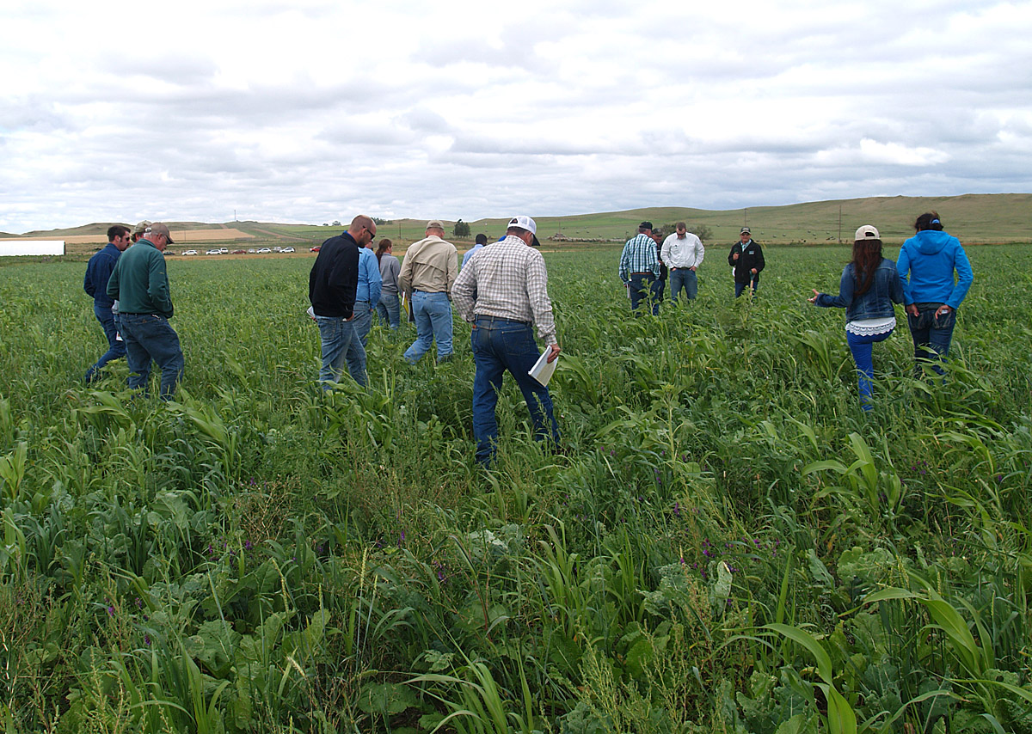“Our research has shown that deviating from traditional beef production practices and adopting non-traditional methodologies can provide opportunities for profitability,” Landblom said.

The team found many positive results that included improved cattle performance, improved soil health, able to use less inputs for crops, and improved crop yields over time, among other results.

“Strategically planting cover crops in the rotation before higher value crops improved soil nutrient cycling and supported grain production with less inputs, while simultaneously providing a long-term forage sequence for yearling steers before feedlot entry,” Senturklu said. “Beef cattle grazing within the crop rotation contributed to positive net returns.”

Cover crops on the DREC ranch contributed to the SWCS Merit Award.

In 2011, the DREC team began a five-year rotation of sunflower, corn, pea-barley, cover crops and wheat, both rotational and continuous as a control.

Yearling beef steer cattle grazed unharvested cover-crops, pea-barley forage and BMR grazing corn.

“Integrated crop rotation and cattle grazing system has had an important impact on soil health and has the potential due to nutrient cycling and soil nitrogen mineralization to reduce commercial fertilizer requirement,” Senturklu added.

The Merit Award is given in recognition of an outstanding activity that promotes the conservation of soil, water, and related natural resources. There were many criteria for the award, including that the activity affected a large area, at least a large part of a state or province, or parts of several states or provinces.