*701.652.2951*

*Fax 701.652.2055*

[*NDSU.Carrington.REC1@ndsu.edu*](mailto:NDSU.Carrington.REC1@ndsu.edu)

*www.ag.ndsu. edu/CarringtonREC/*

## North Dakota State University

### Carrington Research Extension Center

#### North Dakota Agricultural Experiment Station

*663 Hwy. 281 North, P.O. Box 219*

*Carrington, ND 58421-0219*

**NDSU**

February 10, 2020

To: Potential Cooperators in Corn Performance Tests

Re: 2020 Entry Form for Carrington Research Extension Center

On behalf of the NDSU Carrington Research Extension Center, we would like to extend an invitation to your seed company or representative to submit entries in our performance tests for corn grain hybrids in 2020. The Carrington Research Extension Center will again be conducting performance tests of corn hybrids at our six traditional environments in 2020. These include the “Carrington Dryland”, “Carrington Irrigated”, and “Carrington Conventional/Non-GMO” tests at our main research site 3 1/2 miles north of Carrington. A fourth performance test is offered at the CREC’s Fingal off-station site located in southeast Barnes County. The final two sites “Oakes Irrigated” and “Oakes Dryland” are located at or near the CREC’s Oakes Irrigation Research Site south of Oakes, North Dakota. The ‘Oakes Dryland’ site is planted on a Barnes Svea loam soil located north of Oakes. We have included a map of North Dakota to show the locations of the trials managed by the CREC for your convenience.

Each of these research environments are considered a separate evaluation site. Preliminary reports are e-mailed as early as possible after trial harvest to our cooperators and posted on the CREC homepage utilized by both farmers and consulting agronomists. Research results are published in the CREC’s annual report that is available to growers, Extension agents, and others in December. The data are also included in a summary of corn performance trials conducted across NDSU in Extension Service Bulletin A-793-REC.

All corn performance tests are established on ground that was planted to a broadleaf crop or a small grain the year before. Each trial is managed utilizing the best management practices appropriate for each location. The hybrids are evaluated using a four (4) replicate design with individual plots 2 rows wide by 30 feet in length (25 ft. at Oakes).

The corn performance tests coordinated among the NDSU Research Extension Centers are conducted with a uniform fee that in 2020 will be two hundred fifty dollars ($250 US) per hybrid, per test location. Associated with this letter is an entry form contract that must be completed indicating corn hybrid entries and test location for trials coordinated by the Carrington Research Extension Center. Inclusion of the following information would be appreciated:

- Brand name. - Trial location, please specify:

- Hybrid identification. - Carrington Dryland, Carrington Irrigated, Carrington Conventional

- Hybrid relative maturity. - Fingal/Barnes County Dryland

- Hybrid technology traits. - Oakes Dryland, Oakes Irrigated

The return of the completed contract form, 2 pounds of seed per location, and payment must be received no later than April 6, 2020, for inclusion in this year’s field tests. Seed should be shipped to the CREC Agronomy Laboratory at 671 Hwy. 281 NE, Carrington, ND 58421. I will return a copy of the completed contract upon receipt of entry fees.

There will be no refunds in the event of a natural disaster such as flooding, hail or blizzard snow pack that renders plots unharvestable.

Respectfully,

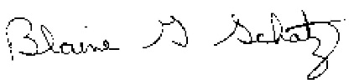 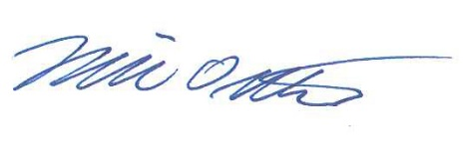

Blaine G. Schatz Mike Ostlie, Ph.D.

Director/Agronomist Research Agronomist

Attachment

**2020 Carrington REC Corn Hybrid Testing Locations**

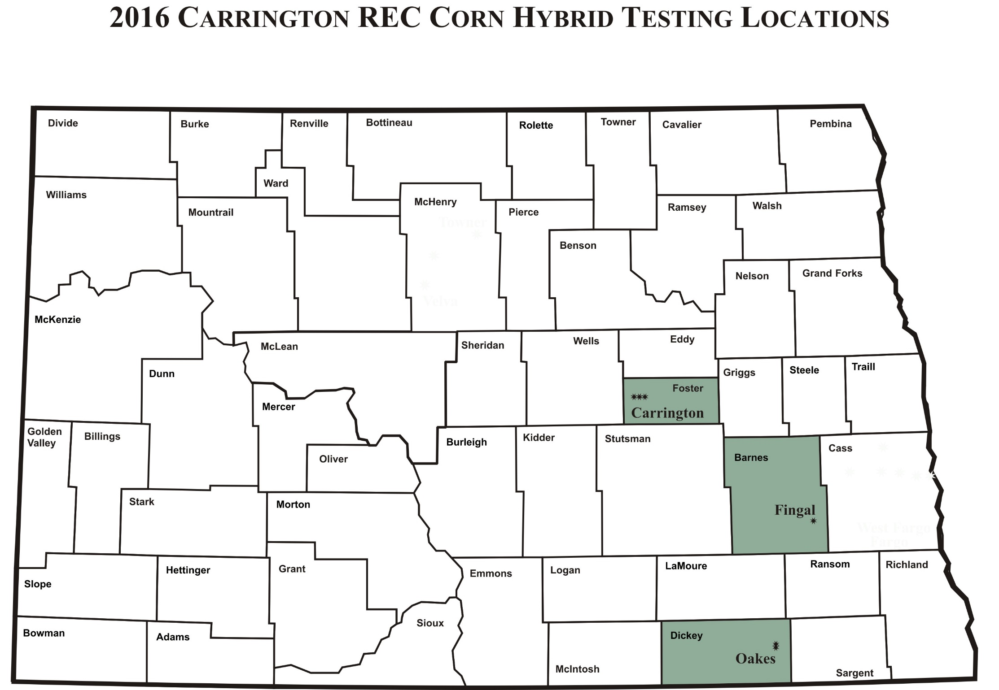

# Corn Hybrid Testing Contract

North Dakota State University

Agricultural Experiment Station

**Corn Hybrid Performance Testing Contract No. 2020** between the Agricultural Experiment Station *Carrington Research Extension Center* at Box 219, Carrington, ND 58421 and       at      . The Seed Supplier agrees to furnish **2 lbs. of seed per test location** for each of the following hybrids to be entered at each of the following locations.

## Identification of Hybrid

(Supplementary entry list may be attached)

|  |  |  |  |  |  |  |  |  |  |
| --- | --- | --- | --- | --- | --- | --- | --- | --- | --- |
| **Brand** | **Hybrid** | **Relative Maturity** | **Technology Traits** | **Carrington Dryland** | **Carrington Irrigated** | **Carrington Conventional** | **Fingal Dryland** | **Oakes Dryland** | **Oakes Irrigated** |
|  |  |  |  |  |  |  |  |  |  |
|  |  |  |  |  |  |  |  |  |  |
|  |  |  |  |  |  |  |  |  |  |
|  |  |  |  |  |  |  |  |  |  |
|  |  |  |  |  |  |  |  |  |  |
|  |  |  |  |  |  |  |  |  |  |
|  |  |  |  |  |  |  |  |  |  |
|  |  |  |  |  |  |  |  |  |  |
|  |  |  |  |  |  |  |  |  |  |
|  |  |  |  |  |  |  |  |  |  |
|  |  |  |  |  |  |  |  |  |  |
|  |  |  |  |  |  |  |  |  |  |
|  |  |  |  |  |  |  |  |  |  |

The Seed Supplier also agrees to pay a total amount of $     , based on a unit charge of $250.00 (US) per entry for each location, on or before April 6, 2020 for testing during the 2020 Crop Growing Season. Please make checks payable to the Carrington Research Extension Center in U.S. funds and return with this entry form.

The Experiment Station will plant, maintain and harvest all plantings in a manner consistent with accepted practices for a given crop. Observations to be made by investigator will include planting and harvesting dates, crop maturity, yields, climatic data and such other information that may be mutually agreed upon between investigator and supplier of seed. All data collected will be published in an appropriate North Dakota Agricultural Experiment Station and/or Extension publication on a timely basis. Data from these North Dakota Agricultural Experiment Station trials shall not be used in advertising to indicate North Dakota Agricultural Experiment Station recommendation of any specific cultivar or hybrids.

SEED SUPPLIER AGRICULTURAL EXPERIMENT STATION

Authorized Representative: Investigator:

e-mail:

(results will be e-mailed, please write legibly)

Date:      Date: