NDSU

North Dakota State University

Carrington Research Extension Center

North Dakota Agricultural Experiment Station
663 Hwy. 281 North, P.O. Box 219
Carrington, ND 58421-0219
701.652.2951
Fax 701.652.2055
NDSU.Carrington.REC1@ndsu.edu
www.ag.ndsu. edu/CarringtonREC/

February 20, 2018

To: Potential Cooperators in Corn Performance Tests

Re: 2018 Entry Form for Carrington Research Extension Center

On behalf of the NDSU Carrington Research Extension Center, we would like to extend an invitation to your seed company or representative to submit entries in our performance tests for corn grain hybrids in 2018. The Carrington Research Extension Center will again be conducting performance tests of corn hybrids at our five traditional distinct environments in 2018. These include the “Carrington Dryland” and “Carrington Irrigated” tests at our main research site 3 miles north of Carrington. A third performance test is offered at the CREC’s Fingal off-station site located in southeast Barnes County. The final two sites are located at or near the CREC’s Oakes Irrigation Research Site south of Oakes, North Dakota, one irrigated and one dryland. The ‘Oakes Dryland’ site will be on a Barnes Svea loam soil located north of Oakes. In 2018 the CREC will again conduct a sixth trial that is focused on the evaluation of “conventional” non-GMO corn hybrids. This trial will be conducted at the main CREC research site under dryland conditions. We have included a map of North Dakota to show the locations of the trials managed by the CREC for your convenience.
Each of these research environments are considered a separate evaluation site. Preliminary reports are e-mailed as early as possible after trial harvest to our cooperators and are also posted on the CREC homepage utilized by both farmers and consulting agronomists. Research results are published in the Carrington Research Extension Center’s annual report that is available to growers, Extension agents, and others in December. The data are also included in a summary of corn performance trials conducted across NDSU in Extension Service Bulletin A-793-REC.
All corn performance tests (Carrington Dryland, Carrington Irrigated, Carrington Conventional, Fingal Dryland, Oakes Dryland, and Oakes Irrigated) are established on ground that was planted to a broadleaf crop or a small grain the year before. Each trial is managed utilizing the best management practices appropriate for each location. The hybrids are evaluated using a four (4) replicate design with individual plots 2 rows wide by 30 feet in length (25 ft. at Oakes).
The corn performance tests coordinated among the NDSU Research Extension Centers are conducted with a uniform fee which in 2018 will be two hundred fifty dollars ($250 US) per hybrid, per test location. Associated with this letter is an entry form contract that must be completed indicating corn hybrid entries and test location for trials coordinated by the Carrington Research Extension Center. Inclusion of the following information would be appreciated:
- Brand name. - Trial location, please specify:
- Hybrid identification. - Carrington Dryland, Carrington Irrigated, Fingal Dryland
- Hybrid relative maturity. - Oakes Dryland, Oakes Irrigated.
- Hybrid technology traits. - Carrington-Conventional (non-GMO)

The return of the completed contract form, 2 pounds of seed per location, and payment must be received no later than April 9, 2018, for inclusion in this year’s field tests. Seed should be shipped to the CREC Agronomy Laboratory at 671 Hwy. 281 NE, Carrington, ND 58421. I will return a copy of the completed contract upon receipt of entry fees.

Respectfully,
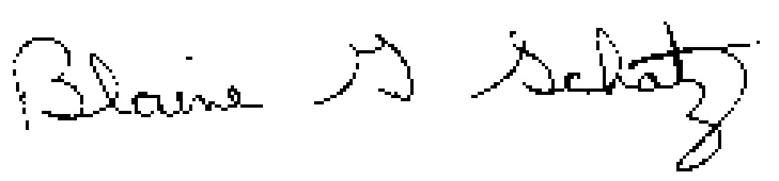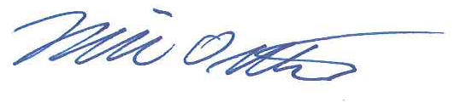
Blaine G. Schatz Mike Ostlie, Ph.D.
Director/Agronomist Research Agronomist

Attachment

2018 Carrington REC Corn Hybrid Testing Locations

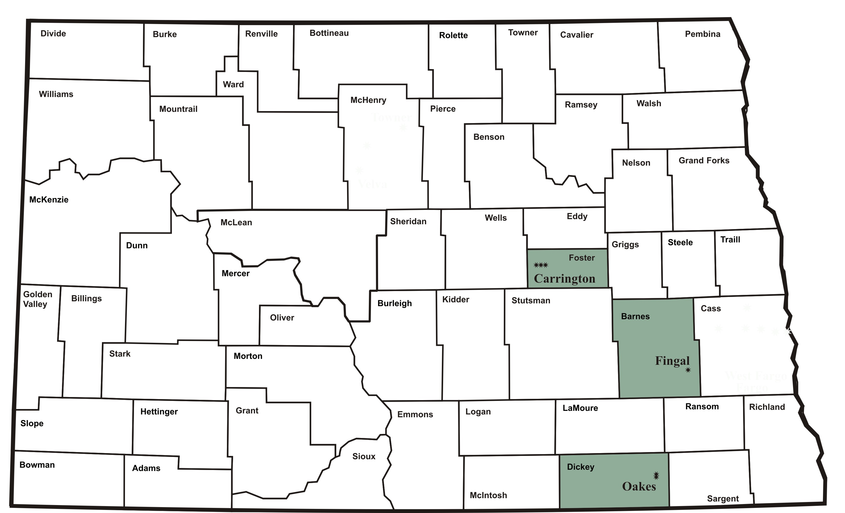

Corn Hybrid Testing Contract
North Dakota State University
Agricultural Experiment Station

Corn Hybrid Performance Testing Contract No. 2018 between the Agricultural Experiment Station Carrington Research Extension Center at Box 219, Carrington, ND 58421 and at . The Seed Supplier agrees to furnish 2 lbs. of seed per test location for each of the following hybrids to be entered at each of the following locations.

Identification of Hybrid
(Supplementary entry list may be attached)
Brand | Hybrid | Relative  Maturity | Technology Traits | Carrington Dryland | Carrington Irrigated | Carrington Conventional | Fingal Dryland | Oakes Dryland | Oakes Irrigated

The Seed Supplier also agrees to pay a total amount of $ , based on a unit charge of $250.00 (US) per entry for each location, on or before April 9, 2018 for testing during the 2018 Crop Growing Season. Please make checks payable to the Carrington Research Extension Center.

The Experiment Station will plant, maintain and harvest all plantings in a manner consistent with accepted practices for a given crop. Observations to be made by investigator will include planting and harvesting dates, crop maturity, yields, climatic data and such other information that may be mutually agreed upon between investigator and supplier of seed. All data collected will be published in an appropriate North Dakota Agricultural Experiment Station and/or Extension publication on a timely basis. Data from these North Dakota Agricultural Experiment Station trials shall not be used in advertising to indicate North Dakota Agricultural Experiment Station recommendation of any specific cultivar or hybrids.

SEED SUPPLIER AGRICULTURAL EXPERIMENT STATION
Authorized Representative: Investigator:

e-mail:
(results will be e-mailed, please write legibly)
Date: Date:

