NDSU

North Dakota State University

Carrington Research Extension Center

North Dakota Agricultural Experiment Station
663 Hwy. 281 North, P.O. Box 219
Carrington, ND 58421-0219
701.652.2951
Fax 701.652.2055
NDSU.Carrington.REC1@ndsu.edu
www.ag.ndsu. edu/CarringtonREC/

February 12, 2018

To: Potential Cooperators in Canola Performance Tests

Re: 2018 Entry Form for Carrington Research Extension Center

On behalf of the NDSU Carrington Research Extension Center, we would like to extend an invitation to your seed company to submit entries in our performance tests of canola varieties for the 2018 season. In 2018 we will continue to conduct a Roundup Ready canola trial, a Liberty Link canola trial, and a Clearfield canola trial to allow efficiencies in implementing appropriate herbicide strategies. Other varieties such as SU or Conventional types will be evaluated in a separate canola trial if submitted. The canola tests at the CREC are typically established on land that was cropped to a small grain the previous year.
Each cultivar intended for evaluation at the Carrington Research Extension Center must be submitted by your seed company or the designated company representative. Preliminary reports, at times without seed quality analysis, are e-mailed as early as possible after trial harvest to our cooperators and are also posted on the CREC homepage utilized by both farmers and consulting agronomists. Trial results are also published in the Carrington Research Extension Center annual report. The data will be published in the NDSU Extension Bulletin A-1124, a separate multi-location summary of canola performance trials across North Dakota.
The canola performance tests coordinated among the NDSU Research Extension Centers are conducted with a uniform fee which in 2018 will continue to be two hundred fifty dollars ($250 US) per cultivar/hybrid, per test location.
Enclosed is an entry form contract that I ask you to complete indicating canola cultivar/hybrid, specific trial and other requested information. The performance test is open to include both commercial cultivars and experimental lines. The return of the completed contract form, 100 grams of seed per test location, and payment must be received no later than April 5, 2018 for inclusion in this year’s test. Seed should be shipped to our Agronomy Laboratory at 671 Hwy. 281 NE, Carrington, ND 58421. The seed will be packaged after appropriately adjusting for germination and seed size. We would very much appreciate information on seedlot germination percent and seed counts if available. We strongly encourage that the seed you prepare and send for these tests be treated with a seed treatment appropriate for flea beetle control. We appreciate your past cooperation and ask that you abide by the application deadline indicated above. Thank you ahead of time for submitting lines into our 2018 evaluations and we look forward to a very successful growing season.

Respectfully,
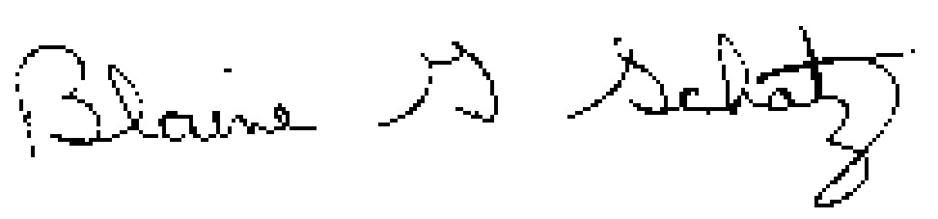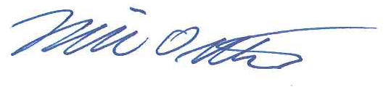
Blaine G. Schatz Mike Ostlie
Director/Agronomist Research Agronomist

Attachment

Canola Cultivar/Hybrid Testing Contract
North Dakota State University
Agricultural Experiment Station

Canola Cultivar/Hybrid Performance Testing Contract No. 2018 between the Agricultural Experiment Station Carrington Research Extension Center at PO Box 219, Carrington, ND 58421 and at . The Seed Supplier agrees to furnish 100 grams of seed for each of the following cultivars/hybrids to be entered at each of the following locations.

Identification Cultivar and/or Hybrid
(See supplementary entry list on next page)
Brand | Cultivar | Cultivar Trait | Cultivar Status | Plant Type | Oil Type | Blackleg Rating

The Seed Supplier also agrees to pay a total amount of $_ , based on a unit charge of $250.00 (US) per entry for each location, on or before April 5, 2018 for testing during the 2018 Crop Growing Season. Please make check payable to the Carrington Research Extension Center.

The Experiment Station will plant, maintain and harvest all plantings in a manner consistent with accepted practices for a given crop. Observations to be made by investigator will include planting and harvesting dates, crop maturity, yields, climatic data and such other information that may be mutually agreed upon between investigator and supplier of seed. All data collected will be published in an appropriate North Dakota Agricultural Experiment Station and/or Extension publication on a timely basis. Data from these North Dakota Agricultural Experiment Station trials shall not be used in advertising to indicate North Dakota Agricultural Experiment Station recommendation of any specific cultivar or hybrids.

SEED SUPPLIER AGRICULTURAL EXPERIMENT STATION
Authorized Representative: Investigator:

e-mail:
(results will be e-mailed, please write legibly)
Date: Date:

