NDSU

North Dakota State University

Carrington Research Extension Center

North Dakota Agricultural Experiment Station
663 Hwy. 281 North, P.O. Box 219
Carrington, ND 58421-0219
701.652.2951
Fax 701.652.2055
NDSU.Carrington.REC@ndsu.edu
www.ag.ndsu.edu/CarringtonREC/

February 10, 2015

To: Potential Cooperators in Soybean Performance Tests.
Re: 2015 Entry Form for NDSU Carrington Research Extension Center directed evaluations.

On behalf of the NDSU Carrington Research Extension Center, I would like to extend an invitation to your seed company to submit entries in our performance tests to evaluate soybean varieties during the 2015 season. As in the past, we will conduct two separate performance tests on-site at the Carrington Center which include our “Dryland” and “Irrigated” environments. In addition to the CREC-based testing sites, we coordinate soybean performance tests at four off-station locations. These locations are sited at our long time off-station location east of Dazey in northern Barnes County, at a site west of LaMoure in LaMoure County, at the CREC’s Oakes Irrigation Research Site in Dickey County, and at our Tri-County site west of Wishek. At all sites, with the exception of the Tri-County site, varieties will be placed into either the ‘Roundup Ready’ or ‘Conventional’ trial so that we may impose appropriate weed management strategies based on variety type. The Tri-County site will only include ‘Roundup Ready’ varieties and depending upon participation, we may need to limit the entry number per company. If a sufficient number of “Liberty Link” varieties are entered into the Carrington Dryland Conventional trial, a separate, specific “Liberty Link” trial may be conducted utilizing appropriate herbicide strategy. A map of North Dakota is included that identifies the location of the CREC research sites for your convenience.
The six locations under our coordination will allow us to best represent potential soybean variety performance in Central, South-Central, East-Central, and Irrigated (high yield) environments. Preliminary reports, typically without seed quality analysis, are e-mailed as early as possible after trial harvest to our cooperators and are also posted on the CREC homepage. Research results from our trials are published in the Carrington Research Extension Center’s annual report that is available to growers, Extension agents, and others in our agricultural industry. The complete data analysis will be e-mailed to all cooperators upon receipt of seed quality data. Data from experimental lines will not be published in state Extension Service circulars but will be included in all CREC based publications.
Each of the performance tests is typically established on ground that was planted to a small grain or corn the year before. Each trial is managed utilizing the best management practices appropriate for each environment. The cultivars will be established in trials using four (4) replicates. A full range of data is collected including yield, test weight, seed weight, seed protein, oil content, heights, lodging, and crop maturation data. In 2015 data on soybean variety iron chlorosis will be collected by Dr. Ted Helms of the NDSU Plant Science Department on those varieties where seed is received by April 7.
The soybean performance tests coordinated among the NDSU Research Extension Centers are conducted with a uniform fee which in 2015 will be two hundred fifty dollars ($250 US) per variety, per test location. Enclosed is an entry form contract that must be completed indicating soybean variety entries and associated information for trials under CREC research leadership. Inclusion of the following information will be required:
- Brand name - Trial site locations - Maturity group rating
- Variety identification - Conventional, Roundup Ready, - Commercial or Experimental
Liberty Link, or RR/STS

The return of the completed contract form, 2 pounds of seed per test site, and payment must be received no later than April 7, 2015 for inclusion in these field trials. An indication of seed count and germination percentage for each of the seedlots submitted for these tests would be appreciated. I will return a copy of the completed contract upon review.

Respectfully,
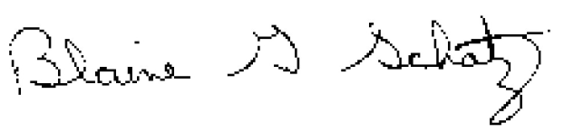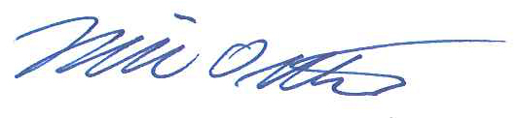
Blaine G. Schatz Mike Ostlie, Ph.D.
Director/Agronomist Research Agronomist

Attachment

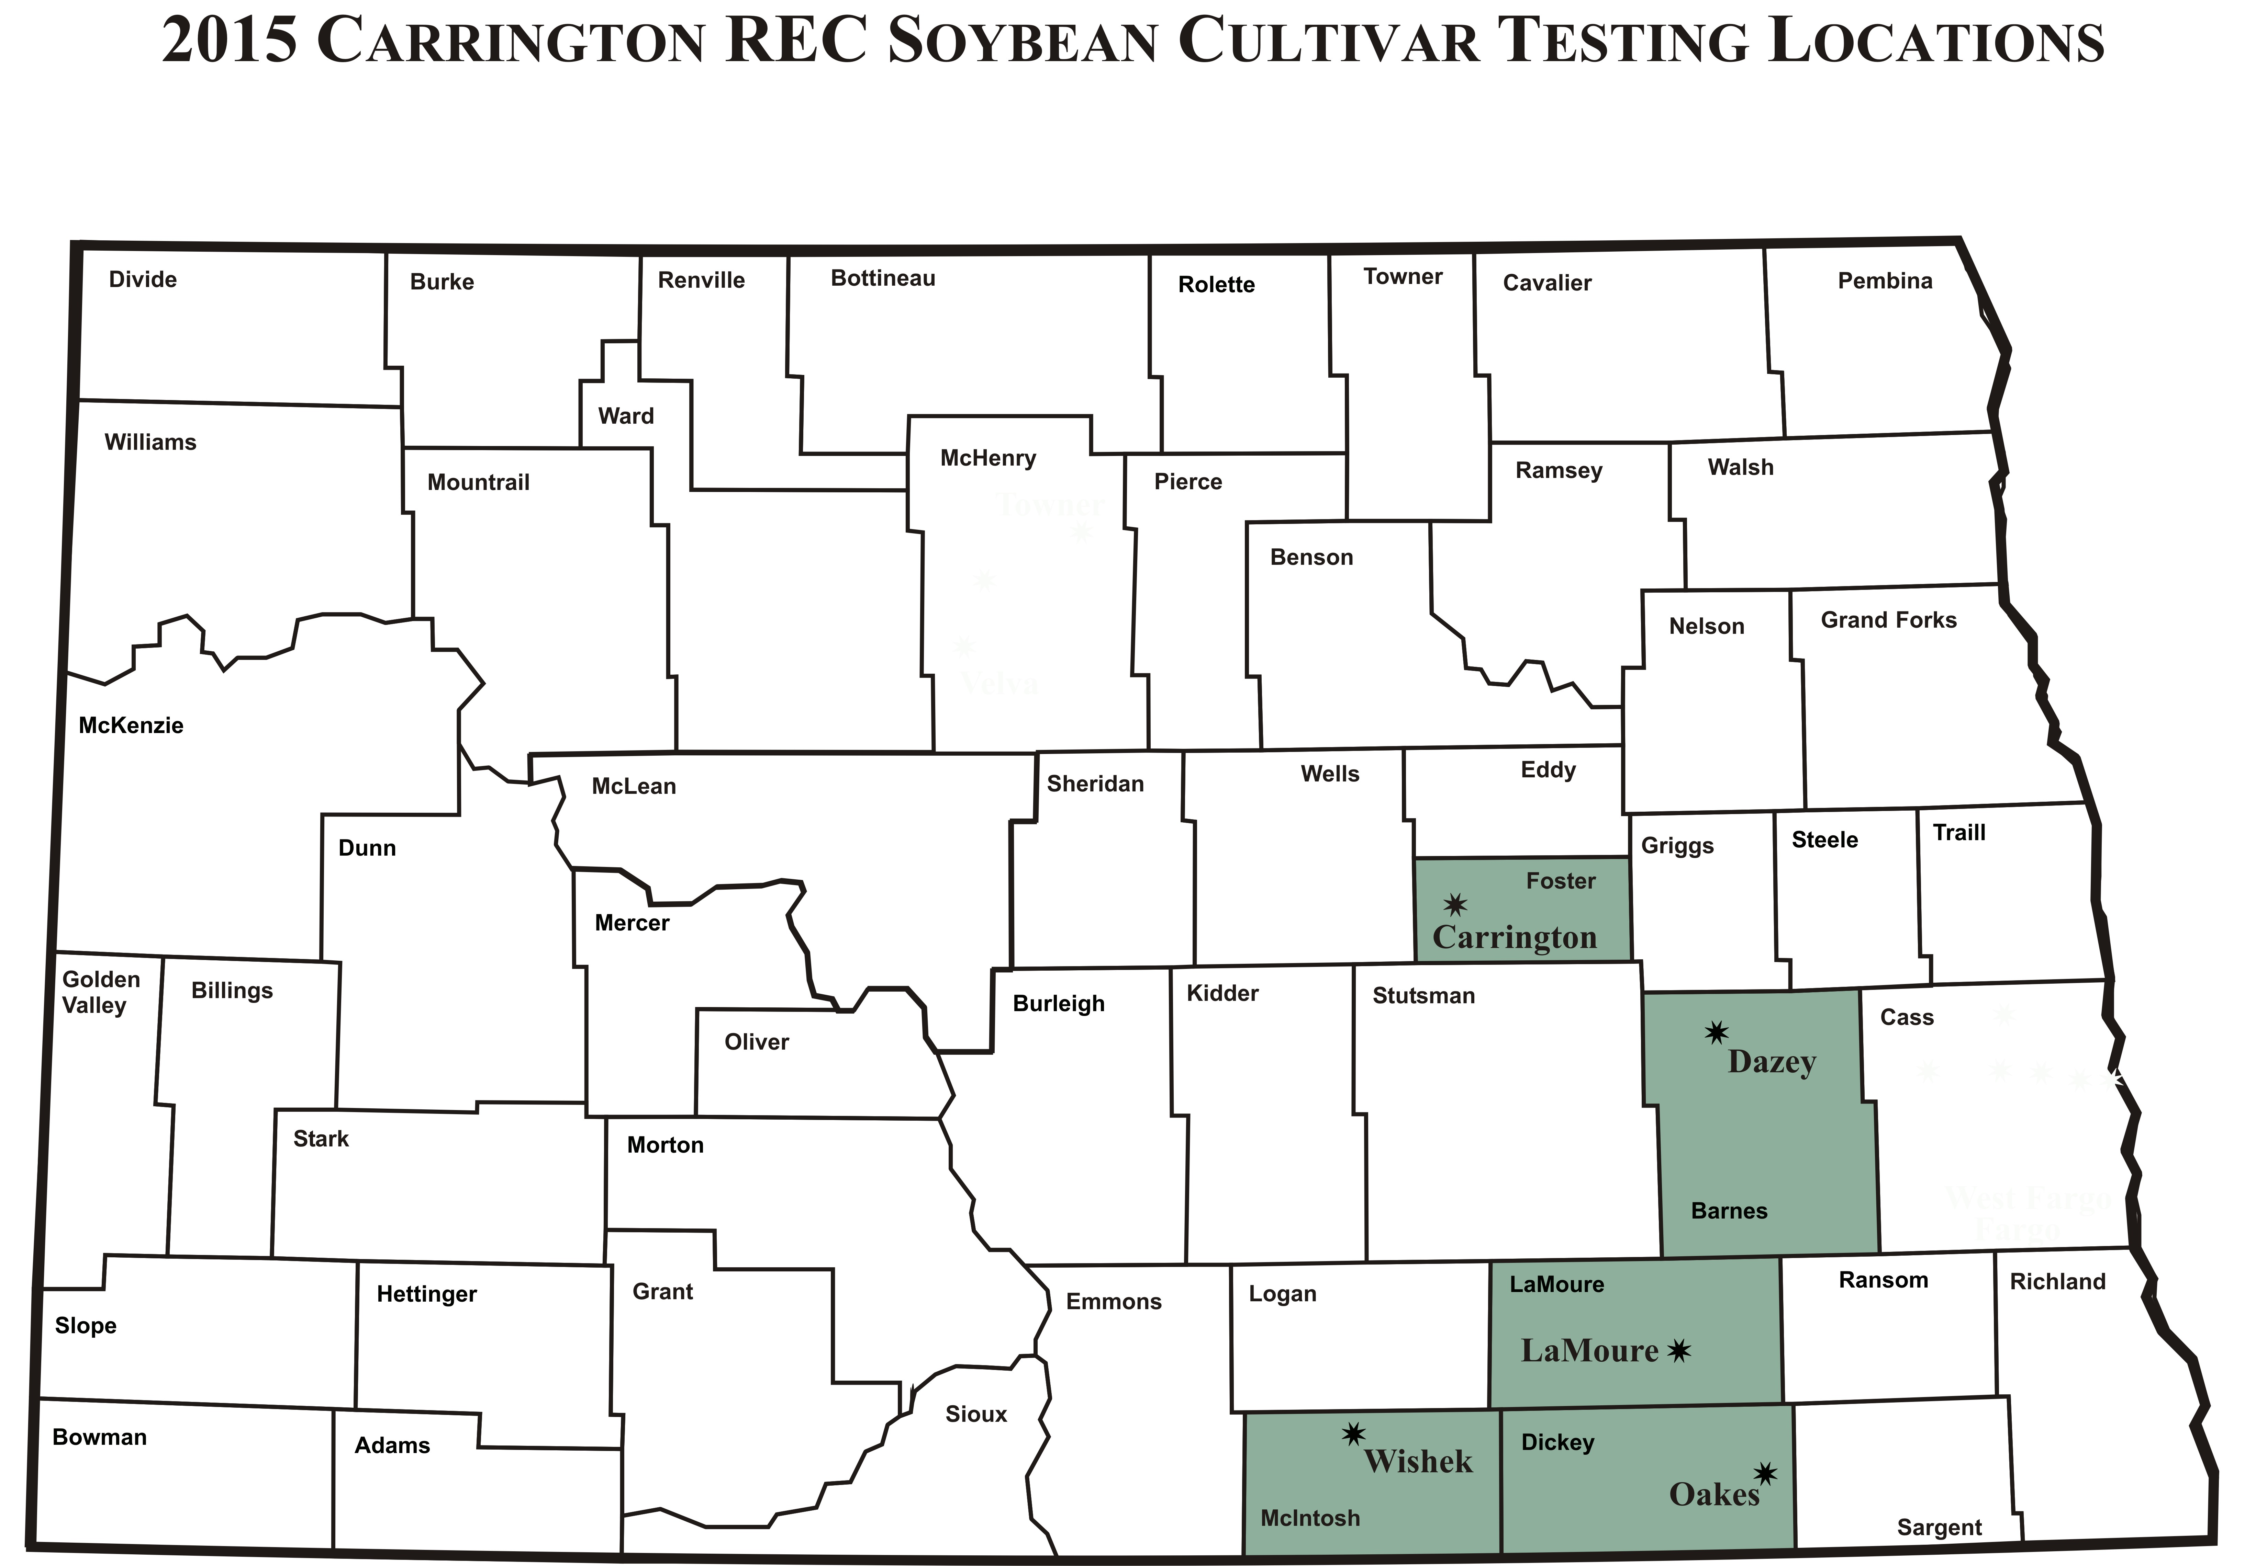

Soybean Cultivar Testing Contract
North Dakota State University
Agricultural Experiment Station

Soybean Cultivar Performance Testing Contract 2015 between the Agricultural Experiment Station Carrington Research Extension Center at PO Box 219, Carrington, ND 58421 and at . The Seed Supplier agrees to furnish 2 lbs. of seed per test location for each of the following cultivars to be entered at each of the following locations.

Identification of Cultivar
(See supplementary entry list on next page)
 |  |  |  |  | ---------- Location ----------
Brand | Cultivar | Cultivar  Trait | Cultivar Status | Maturity Group | Carrington Dryland | Carrington Irrigated | Barnes County | LaMoure County | Oakes Irrigated | Tri-County

The Seed Supplier also agrees to pay a total amount of $ , based on a unit charge of $250.00 (US) per entry for each location, on or before April 7, 2015 for testing during the 2015 Crop Growing Season. Please make checks payable to the Carrington Research Extension Center.

The Experiment Station will plant, maintain and harvest all plantings in a manner consistent with accepted practices for a given crop. Observations to be made by investigator will include planting and harvesting dates, crop maturity, yields, climatic data and such other information that may be mutually agreed upon between investigator and supplier of seed. All data collected will be published in an appropriate North Dakota Agricultural Experiment Station and/or Extension publication on a timely basis. Data from these North Dakota Agricultural Experiment Station trials shall not be used in advertising to indicate North Dakota Agricultural Experiment Station recommendation of any specific cultivar or hybrids.

SEED SUPPLIER AGRICULTURAL EXPERIMENT STATION
Authorized Representative: Investigator:

e-mail:
(results will be e-mailed, please write legibly)
Date: Date:

Identification of Cultivar

 |  |  |  |  | ---------- Location ----------
Brand | Cultivar | Cultivar  Trait | Cultivar Status | Maturity Group | Carrington Dryland | Carrington Irrigated | Barnes County | LaMoure County | Oakes Irrigated | Tri-County  Dryland

