Great Plains Tree Pest Council Meeting
2012 Spring Meeting

Agenda (2 day)

Hosted this year at: K-State Horticulture Research & Extension Center,

35125 W. 135th St., Olathe, KS 66061
913.856.2335
Tuesday April 17, 2012

8:00 – 8:15 AM Coffee

8:15 – 8:30 AM Welcome & introductory remarks

8:30 – 9:00 AM The History of Forestry in Kansas
Speaker: Larry Biles – KFS State Forester

Seminars

9:00 – 9:45 AM Assessing Windbreak Health with Remote Sensing
Speaker: Bob Atchison – KFS Rural Forestry Coordinator

9:45 – 10:30 AM Improving Red Elm Propagation: An important species for Native Americans
Speaker: Charles Barden – Professor & State Extension Forester

10:30 – 11:30 AM Pine Wilt Vectors & “Insect Borers” of Kansas
Speaker: Bob Bauernfeind – Professor & Extension Specialist

11:40 – 12:50 PM

LUNCH BREAK Provided with registration fee

12:50 – 1:45 PM Continued Conifer Work in Kansas
Speaker: Jason Griffin – Ornamental Trees & Shrubs Specialist

1:45 – 2:00 PM Relative resistance of Rocky Mountain Region pines to Diplodia pinea
Speaker: J.T. Blodgett – USDA Forest Service, Forest Health Protection
2:00 – 3:00 PM Discussion: Update on Tree Diseases of Great Plains Book

3:00 – 3:15 PM BREAK

3:15 – 4:00 PM Discussion continued & GPTPC attending N.A. Int’l Forest Disease Workshop
Possible resurrection of the old GPTPC website

4:00 – 6:00 PM History of Forestry at Sunflower and Research Station along with guided tour of the ammunition plant and relic trees
Speakers: John Strickler & Bill Maasen – JCPRD Sup. of Parks & Golf Courses
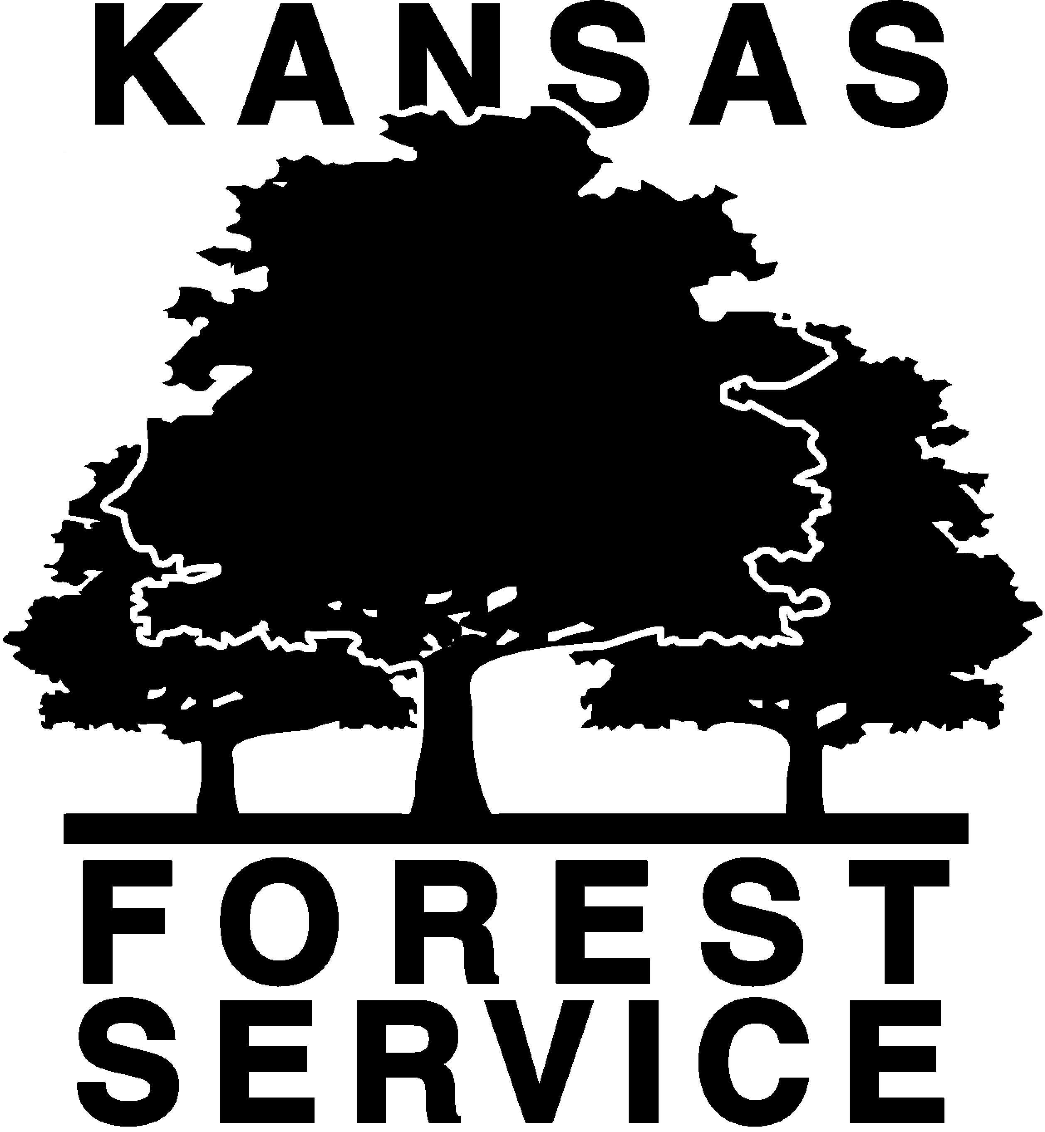
Dinner on your own

Great Plains Tree Pest Council Meeting
2012 Spring Meeting

Agenda

K-State Horticulture Research & Extension Center, Olathe, KS
Wednesday April 18, 2012

8:00 – 8:15 AM Coffee

8:15 – 9:00 AM Continued discussion if need or State Reports

9:00 – NOON State Reports (30 minutes per state max – including discussion)

WORKING

LUNCH BREAK Provided with registration fee

NOON – 12:30 PM General Membership Business Meeting. Changing of the Guard, Nominations/Election for board member positions

1:00 – 4:00 PM American Walnut Company Tour (drive time included)
***Eye and ear protection needed. I may have ear plugs for 5 or so people but eye glasses or safety glasses need to be provided on your own.

4:00 – 6:00 PM Dinner together – On your own

Hotel Information:
Comfort Suites
12070 S. Strang Line Rd., Olathe, KS, US, 66062
Phone: (913) 397-0100
Fax: (913) 397-9559
Check in on Monday the 16th and check out the 19th for those that decide to stay later.
Currently 15 rooms are being held - more can be added.
Please make your reservations before the 31st of March.
* Free hot breakfast
* Free wireless high-speed Internet access in all suites and public areas
* Free The Wall Street Journal
* Free local calls
* Manager's reception (Monday - Thursday) with beer, wine, soda and appetizers
Link: http://www.comfortsuites.com/hotel-olathe-kansas-KS047

