Soil & Community Health Agriculture Education Site
The Situation
Local hospital, Dickinson CHI St. Alexius Health, had a plot of land that they were not able to maintain and it quickly became covered in weeds. The soil had been abused from multiple construction projects. A collaboration with the
hospital created the Soil & Community Health Agriculture Education Site.

Extension Response
Demonstrations were planned for the site, however there were many obstacles in getting crops to grow at the site, including compaction, herbicide residual, and drought stress. Demonstrations were planned showing cover crop species, a cover crop mix, water infiltration, cropping systems trial, and soil pit.

Impact
Two workshops planned at the site provided information to local producers, agronomists and seed dealers, and ANR agents. The first workshop on August 18th 2016 included presentations from Ryan Buetow and Marisol Berti on current cover crop work in the region and the benefits of cover crops. Doug Landblom from the Dickinson Research Extension Center also spoke about the work that was being done at the Dickinson Research Extension Center Ranch near Manning, ND. At the second workshop on October 13th 2016 presentations from Jon Stika, Ryan Buetow, and Kurt Froelich included information on water infiltration, effect of crop rotation and management on soil erosion, and the influence of plants and soil biology on soil structure.
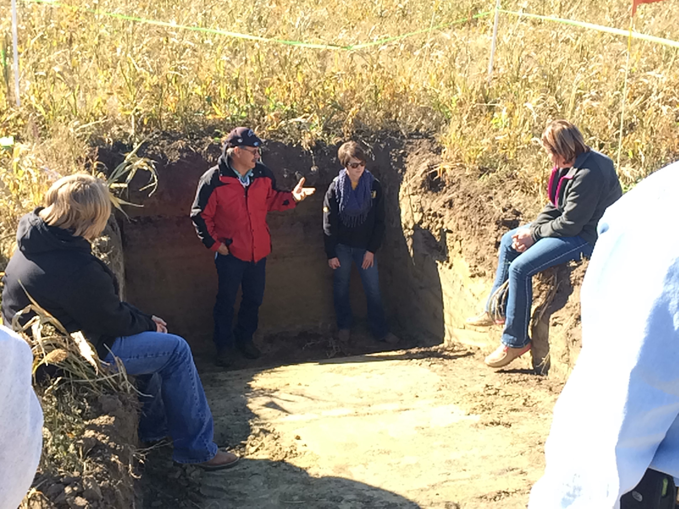
Kurt Froelich discussing soil structure at the workshop on October 13th 2016.
Public Value Statement
Strengthening the relationship between NDSU Research and Extension Centers builds trust, community health and relationships with the local community.
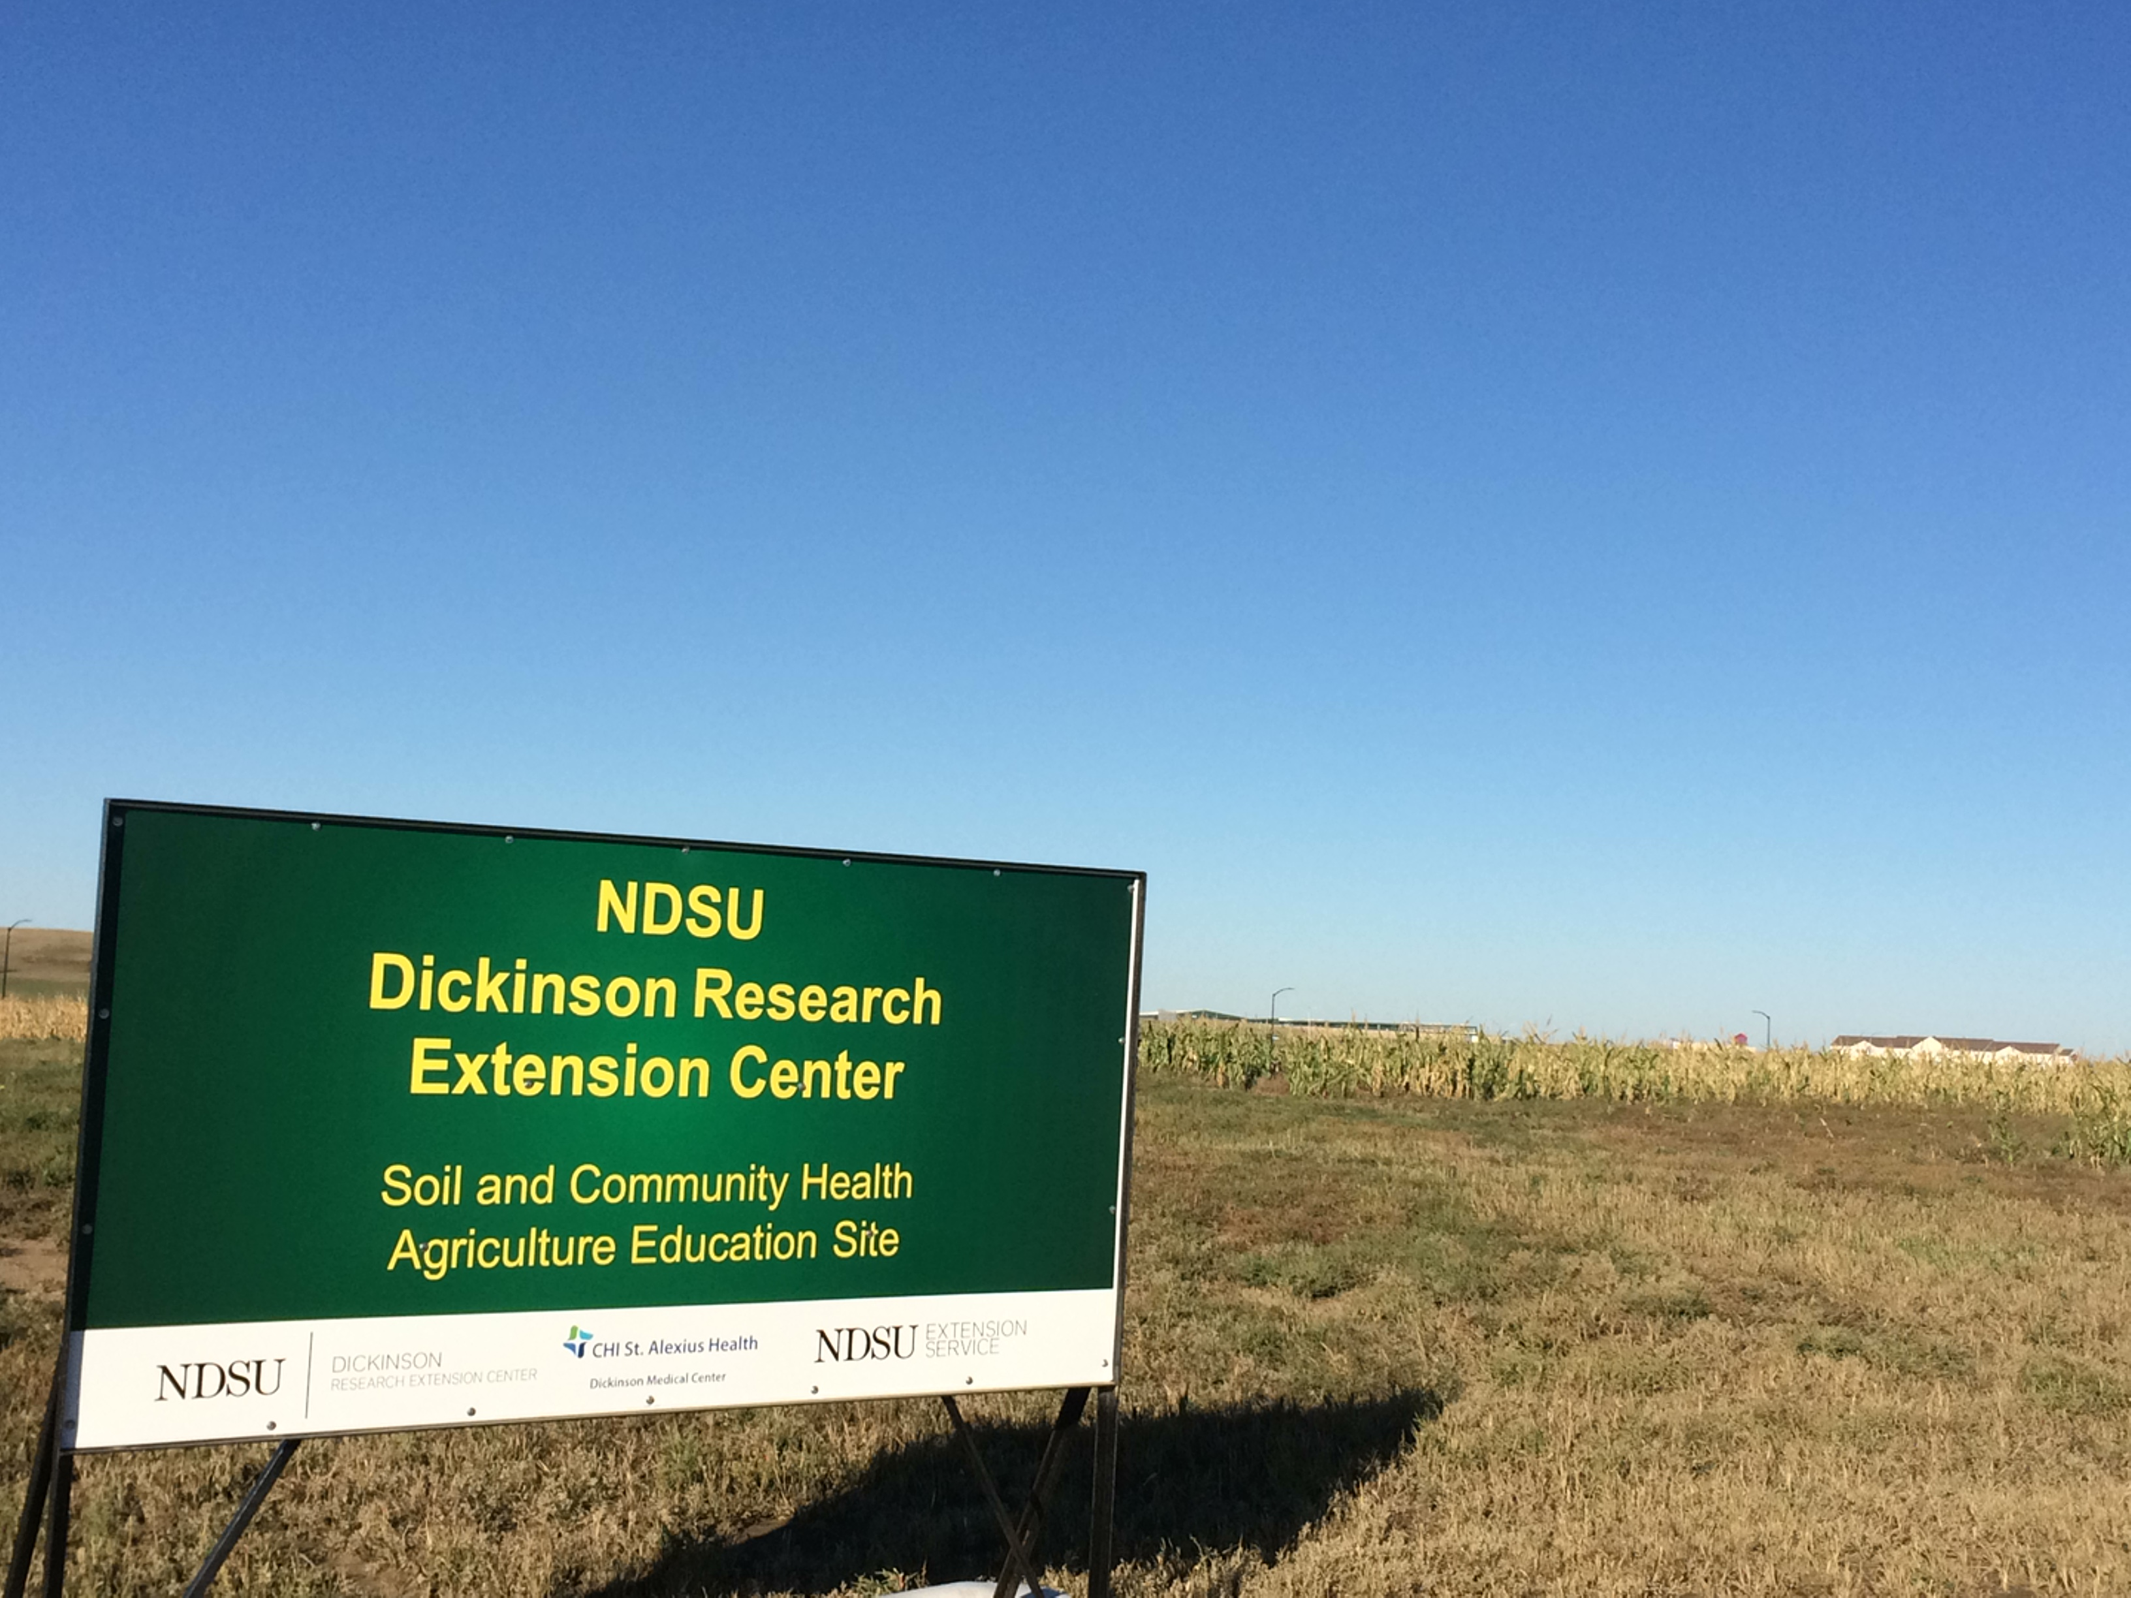
The Soil & Community Health Agriculture Education Site is located in Dickinson, ND to the west of the Dickinson Research Extension Center on Empire Road.
Primary Contact
Ryan Buetow
NDSU Area Extension Specialist/Cropping Systems
1041 State Avenue, Dickinson, ND 58601
701-456-1106
Ryan.buetow@ndsu.edu

