**Effect of Extreme Drought on Crop Rotation and Soil Physical and Microbial Property Changes for the period 2016-2019 in Western North Dakota**

**D.G. Landblom1, S. Senturklu1, 2, L. Cihacek3, J. Steffan4**

1 Dickinson Research Extension Center, North Dakota State University, Dickinson, North Dakota

2 Department of Animal Science, Canakkale Onsekiz Mart University, Canakkale, BMYO, Turkey

3 Soil Science Department, North Dakota State University, Fargo, North Dakota

4 Department of Natural Sciences, Dickinson State University, Dickinson, North Dakota

**Introduction**

A 10-year integrated crop and livestock study was initiated in 2011 that compared hard red spring wheat grown continuously (HRSW-C) to hard red spring wheat grown in a five-crop rotation (HRSW-R). For the rotation, the sequence of crops consisted of HRSW-R, dual winter and spring cover crops, silage corn, field pea-forage barley mix, and sunflower. Beef cattle are integrated into the systems evaluation due to the importance of grazing to soil biological activity and the potential economic advantages grazing annual forages in an integrated system. As such, the winter triticale-hairy vetch cover crop mix is put up as hay, and the other crops: post-hay harvest 13-specie cover crop, pea-barley mix, and corn are grazing crops for yearling beef steers (Senturklu et al., 2017, 2018, 2019).

A research summary for the first 5-year rotation (2011– 2015) of the 10-year study, provides a description of the research procedures and a brief summary of crop yields, soil organic matter, nitrogen fertility, nutrient cycling, fertilizer reduction, and economics (Landblom et al., 2017). The second 5-year rotation, after four years of data collection, has been negatively affected by hail, wind, and drought resulting in low yields and fluctuating soil microbial properties.

This report summarizes crop yields to date for spring wheat grown continuously (Control) and spring wheat grown in a five-crop rotation for crop years 2016 through 2019 of the 2nd 5-year crop rotation. At this writing, 2020 crop planning is in progress.

**Materials and Methods**

For a description of the methods used in this research project, the reader is directed to Landblom et al. (2017) for the project design, seeding and planting detail, plant population goals, weed control, growing season soil fertility, economic analysis, and a summary for the first five years of the study (2011-2015).

To evaluate crop yield solely on microbial nutrient mineralization, nitrogen fertilizer was discontinued after the 2013 crop year for the spring wheat-C and after the 2012 spring wheat-R crop year.

In addition to growing season soil fertility and soil physical property change, soil microbial analysis determined from two tests provided by Ward Laboratories, Inc., Kearney, NE, i.e. Phospholipid Fatty Acid (PLFA) microbial community analysis and the Haney Soil Health Test.

Soil samples were collected in the 0.0-6.0” rooting zone for the PLFA Microbial Community and Haney Soil Health Test. Thirteen soil samples were collected from each of the 18 field replicates in an “X” transect pattern (3 from each leg of the X and one in the center) and composited. The samples were immediately placed in plastic bags, air squeezed out, sealed, and stored in a cooler on ice. In the lab, the samples were frozen and subsequently shipped on ice to Ward Laboratories, Inc. for analysis. Samples were collected August 27, 2017 and August 29, 2019. The PLFA analysis reports provide results for the following: total biomass and diversity index, total bacteria biomass, total Actinomycetes biomass, gram (-) biomass, gram (+) biomass, gram (+): gram (-) ratio, rhizobia biomass, total fungi biomass, Arbuscular mycorrhizal biomass, saprophytes biomass, protozoa biomass, undifferentiated biomass, fungi: bacteria ratio, and saturated: unsaturated fatty acid ratio.

The Haney test analysis provided results for the following tests: pH, soluble salt, soil organic matter, CO2-carbon, water soluble total N, water soluble organic N, water soluble total organic carbon, NO3-N, NH4-N, inorganic N, total phosphorus, inorganic phosphorus, organic phosphorus, potassium (K), calcium (Ca), aluminum (Al), iron (Fe), sulfur (S), zinc (Zn), manganese (Mn), copper (Cu), magnesium (Mg), sodium (Na), percent microbial active carbon, organic C: N ratio, organic N: inorganic N, organic N release, and soil health calculation. Included in the report are traditional N-P-K values, nutrient value (value of nutrients in the soil; $/Ac), traditional lbs. of NO3-N in the soil/Ac, Haney test available lbs. of N in the soil/Ac, N difference in lbs./Ac between traditional N and Haney microbial derived N in lbs./Ac, and N savings in $/Ac by accounting for microbial derived N/Ac.

**Results and Discussion**

Precipitation during the first five-year rotation was variable, although, generally production was very good. Production for the second five-year period, in which the first four years have been completed, has been very different from the first five years and plagued with multiple environmental insults. The 2016 production year precipitation was considered normal for western ND, however, hail reduced spring wheat yields. The 2017 crop year for the region was rated as an extreme to exceptional drought by the U.S. Drought Monitor (June 27 - Figure 1; August 29 - Figure 2). Regional growing-season precipitation for the 2018 crop improved as indicated by the U.S. Drought Monitor (June 26 - Figure 3; August 28 – Figure 4) and crop yields improved somewhat. The 2019 growing-season precipitation was normal as indicated by the U.S. Drought Monitor (June 25 - Figure 5; August 27 - Figure 6).

Control and rotation spring wheat yields for the period from 2016 through 2019 are shown in Chart 1. Compared to 2016 spring wheat-C was 39.6, -3.14, and 16.9% in 2017, 2018, and 2019, respectively. And for spring wheat-R grown in the five-crop rotation, compared to 2016 yield, yields were -6.46, -18.7, and 24.5% in 2017, 2018, and 2019, respectively.

Crop yields for rotation crops (triticale-hairy vetch, cover crop, corn, pea-barley, and sunflower) are shown in Chart 2. With the exception of corn yield, which did not change much during the four-year period, 2018 yields improved compared to 2017. However, compared to 2016, 2018 yield for pea-barley, cover crop, triticale-hairy vetch, and sunflower were -25, -90, -59.3, and -15.5% less, respectively. Comparing 2019 rotation crop yield to 2016 yield, pea-barley and cover crop were -38.8 and -76.0% less whereas triticale-hairy vetch and sunflower were 25.4 and 17.7% more.

Haney test results comparing the 2017 drought with the 2019 cropping season are shown in Table 1. The 2017 drought year began with moist soils. The advancing growing season with significantly reduced precipitation dried soils and inhibited microbial activity. Microbes exist in soil in massive numbers and conform to the soil environment and adapt to soil temperature, water content, soil type, and the amounts of available SOM substrate that supports them. The SOM is subject to cropping systems ranging from monocultures to diverse crop rotations that supply a variety of root and residue substrates that are decomposed and mineralized from organic states to inorganic states utilized by growing plants. Lack of adequate soil water for soil nutrient solubilization and translocation negatively impacts a very complex biological system of microbial activity, nutrient translocation processes, and plant growth. Table 1 shows the extent of change comparing dry soil in 2017 with moist soil in 2019 for pH, soluble salt, soil organic matter, CO2-C release, microbial active carbon percent, organic C: N ratio, organic N: inorganic N ratio, and organic N release. With drying, soluble salts became more concentrated resulting in a pH decline and more acidic soil conditions and reduced root activity resulted in SOM decline across all treatments and crops. Microbial active carbon percent, organic C:N ratio, and organic N:inorganic N ratio also declined across treatments and crops except for the dual cover crop and sunflower. Under drought conditions, microbially active carbon was likely being lost and affected soil buffering reactions, and organic N release from soil in all treatments and crops was approximately 200% greater compared to moist conditions in 2019.

While the Haney Test provided results of 24-hour microbial respiration, the PLFA microbial analysis provides measurements of the microbial community and organismal diversity. Microbial contrasts comparing crop years 2017 with 2019 is shown in Table 2 and summarizes the effect of water stress on total biological biomass, diversity index, total bacterial biomass, total fungi biomass, and abruscular mycorrhizal fungi biomass. Total living microbial biomass expressed in nanograms/gram (ng/g) were rated as slightly above average in 2017 ranging from 1,466 to 2,021 ng/g and rebounded when adequate soil water conditions returned to amounts ranging from 4,462 to 5,325 ng/g that are rated as excellent for healthy soils. Mean difference, when all crops were averaged, shows the biomass resurgence resulting from adequate soil water. Although microbial population biomass declined with the ensuing drought, organism diversity remained largely unchanged ranging from an average 1.49 in 2017 to 1.51 in 2018 on a scale of 0.0 to 2.0. Soil microbial diversity is rated as good to very good. Given the negative effect reduced soil water has on microbial populations, total bacterial biomass, total fungi biomass, and arbuscular mycorrhizal fungi biomass rebounded after soil water increased by the 2019 cropping season.

Soil minerals potassium (K), calcium (Ca), aluminum (Al), iron (Fe), sulfur (S), zinc (Zn), manganese (Mn), copper (Cu), magnesium (Mg), and sodium (Na) were similar to the concentration increases measured for the microbial soil characteristics as soil drying advanced resulting in mineral concentration during the 2017 crop year; however, soil mineral content increased in 2019 compared to 2017 (Table 3) due to soil water dilution and plant utilization. Cover crop calcium and magnesium; sunflower potassium, calcium, magnesium, and sodium; spring wheat-C calcium and magnesium; corn manganese; pea-barley potassium, manganese, and sodium; and spring wheat-R sodium all increased in 2019 compared to 2017.

Microbial soil analysis will be conducted again during the 2020 cropping season in the integrated system investigation to continue tracking the effect of environment and the cropping-livestock grazing system relationship.

**Acknowledgement**

This research is funded by the NDSU Agricultural Experiment Station and a Sustainable Agriculture Research Education (SARE) grant #LNC16-381.

**Literature Cited**

Landblom, D.G., S. Senturklu, L. Cihacek, and E. Brevik. 2017. Effect of a Multi-Crop Rotation on Soil Health, Spring Wheat and Rotation Crop Yields, and Cropping System Economics in Western North Dakota. In Dickinson Research Extension Center Annual Report, [https://www.ag.ndsu.edu/Dickinson REC/annual-reports-1/2016-annual-report/effect-of-hrsw-5crop-rotation-crp-prod-v4-final-8.pdf](https://www.ag.ndsu.edu/Dickinson%20REC/annual-reports-1/2016-annual-report/effect-of-hrsw-5crop-rotation-crp-prod-v4-final-8.pdf)

Şentürklü, S., D. G. Landblom, R. J. Maddock, T. Petry, and S.I. Paisley. 2017. Effect of yearling steer frame score, grazing sequence, and delayed feedlot entry on grazing and feedlot performance, carcass trait measurements, and systems economics. <https://www.ag.ndsu.edu/DickinsonREC/annual-reports-1/2017-annual-report/2018-ann-rpt-v6-3yr-frm-grazvsflot-update-from.pdf>

Şentürklü, Songul, Douglas G. Landblom, Robert Maddock, Tim Petry, Cheryl, J. Wachenheim, and Steve I. Paisley. 2018. Effect of yearling steer sequence grazing of perennial and annual forages in an integrated crop and livestock system on grazing performance, delayed feedlot entry, finishing performance, carcass measurements, and systems economics. J. Anim. Sci. 96:2204-2218. doi:10.1093/jas/sky150

Şentürklü, S., D. G. Landblom, and S. I. Paisley. 2019. Cover crop bale grazing after annual forage grazing on yearling steer grazing and feedlot performance, muscling, carcass measurements and carcass value. [https://www.ag.ndsu.edu/ DickinsonREC/annual-reports-1/2019-annual-report/3-year-ann-vs-nr-plus-bale-grazing-annual.pdf](https://www.ag.ndsu.edu/%20DickinsonREC/annual-reports-1/2019-annual-report/3-year-ann-vs-nr-plus-bale-grazing-annual.pdf)

Fig. 1. June 27, 2017 Drought Monitor Map Fig. 2. August 29, 2017 U.S. Drought Monitor Map

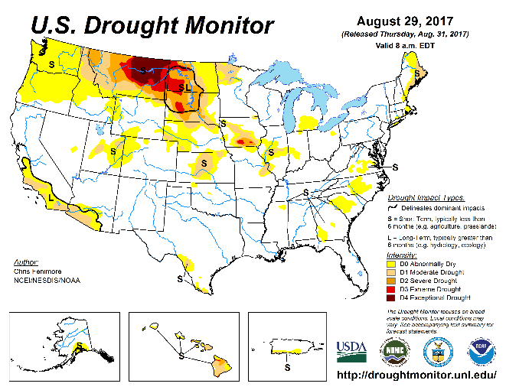

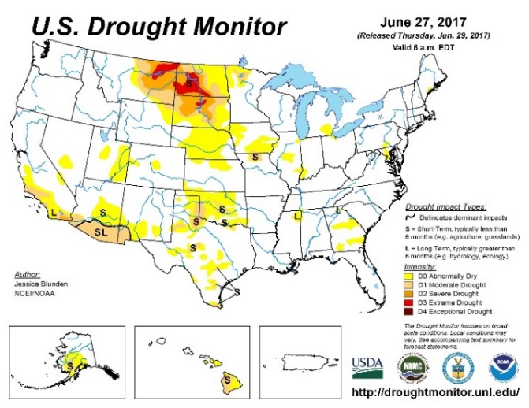

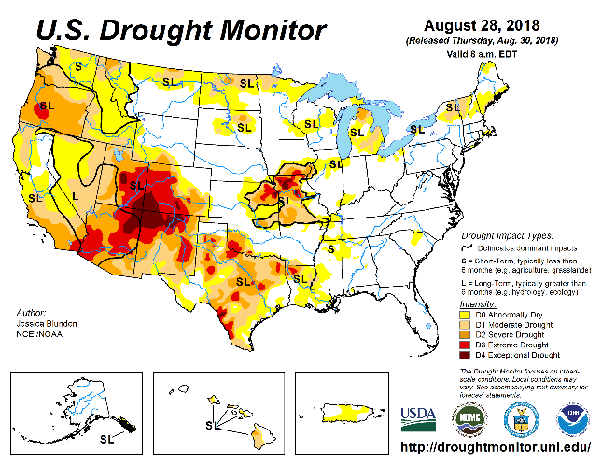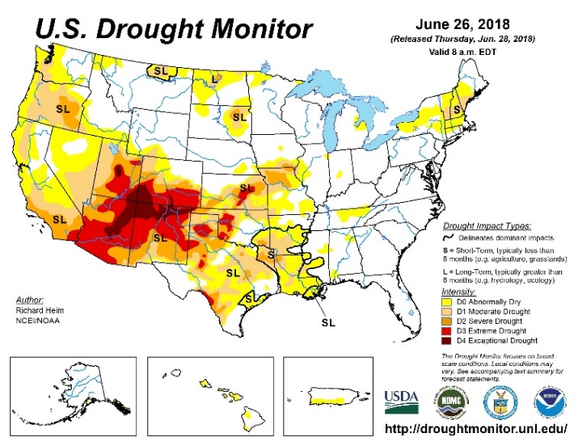Fig. 3. June 26, 2018 U.S. Drought Monitor Map Fig. 4. August 28, 2018 U.S. Drought Monitor Map

Fig. 5. June 25, 2019 U.S. Drought Monitor Map Fig. 6. August 27, 2019 U.S. Drought Monitor Map

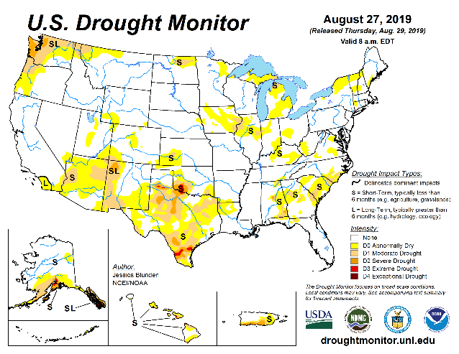

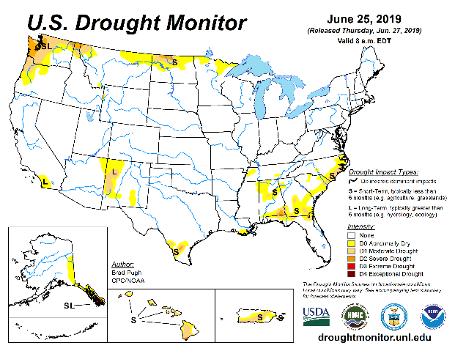

Chart 1. Control and rotation spring wheat yield (2016 through 2019)

Chart 2. Rotation crop yield for crop years 2016 through 2019

Table 1. Haney test microbial analysis for crop years 2017 and 2019

|  |  |  |  |  |  |  |  |  |  |
| --- | --- | --- | --- | --- | --- | --- | --- | --- | --- |
| **Crop** | **Year** | **pH** | **Soluble Salt** | **SOM** | **CO2-C** | **Microbial Active C** | **Organic N:C** | **Organic N: Inorganic N** | **Organic N Release** |
| **Units** |  |  | Mmho/  cm | % | ppm | % | Ratio | Ratio | ppm |
| **C-Crop** | 2017 | 5.6 | 0.20 | 3.53 | 99.8 | 65.1 | 8.13 | 1.93 | 18.8 |
|  | **2019** | **6.9** | **0.10** | **3.80** | **103** | **99.8** | **11.43** | **1.37** | **9.23** |
| **Sun-Flower** | 2017 | 5.4 | 0.18 | 3.30 | 92.9 | 58.9 | 8.57 | 1.83 | 18.33 |
|  | **2019** | **6.5** | **0.09** | **4.23** | **72.5** | **62.2** | **13.17** | **1.53** | **8.9** |
| **SPW-C** | 2017 | 5.9 | 0.22 | 2.93 | 93.5 | 64.8 | 8.87 | 1.73 | 17.27 |
|  | **2019** | **6.0** | **0.07** | **3.37** | **83.4** | **74.6** | **13.2** | **2.00** | **8.37** |
| **Corn** | 2017 | 6.6 | 0.40 | 3.70 | 88.9 | 50.5 | 10.07 | 0.93 | 18.03 |
|  | **2019** | **6.8** | **0.09** | **3.73** | **78.9** | **75.8** | **12.13** | **1.20** | **8.77** |
| **Pea-Bly** | 2017 | 5.8 | 0.21 | 3.10 | 107.9 | 80.6 | 7.93 | 1.40 | 17.57 |
|  | **2019** | **6.3** | **0.08** | **4.80** | **78.5** | **66.6** | **13.13** | **2.10** | **9.03** |
| **SPW-R** | 2017 | 6.4 | 0.25 | 3.17 | 94.63 | 56.8 | 8.83 | 2.00 | 18.87 |
|  | **2019** | **7.0** | **0.08** | **3.87** | **132.1** | **112.9** | **12.43** | **2.23** | **9.37** |
| **Combined** | 2017 | 5.95 | 0.24 | 3.29 | 96.27 | 62.78 | 8.73 | 1.64 | 18.15 |
| **Crops** | **2019** | **6.58** | **0.09** | **3.97** | **91.40** | **81.98** | **12.58** | **1.74** | **8.95** |
| **Ave Diff** |  | 0.63 | -0.16 | 0.68 | -4.87 | 19.20 | 3.85 | 0.10 | -9.20 |

Table 2. Phospholipid Fatty Acid (PLFA) microbial analysis results comparing 2017 with 2019 crop year

|  |  |  |  |  |  |  |
| --- | --- | --- | --- | --- | --- | --- |
| **Crop** | **Year** | **Total**  **Biomass** | **Diversity Index** | **Total Bacterial Biomass** | **Total Fungi Biomass** | **Arbuscular Mycorrhizal Fungi Biomass** |
| **Units** |  | ppm | ppm | ppm | ppm | Ppm |
| **C-Crop** | 2017 | 2021 | 1.39 | 917 | 121 | 45 |
|  | **2019** | **4936** | **1.50** | **2255** | **643** | **172** |
| **S-Flower** | 2017 | 1559 | 1.54 | 751 | 152 | 34 |
|  | **2019** | **5325** | **1.54** | **2298** | **870** | **187** |
| **SPW-C** | 2017 | 1466 | 1.61 | 796 | 155 | 45 |
|  | **2019** | **4485** | **1.49** | **1892** | **488** | **125** |
| **Corn** | 2017 | 1602 | 1.48 | 860 | 149 | 45 |
|  | **2019** | **4938** | **1.50** | **2111** | **615** | **172** |
| **Pea-Bly** | 2017 | 1644 | 1.39 | 832 | 132 | 33 |
|  | **2019** | **4679** | **1.49** | **2078** | **531** | **130** |
| **SPW-R** | 2017 | 1527 | 1.54 | 811 | 167 | 51 |
|  | **2019** | **4462** | **1.54** | **2137** | **422** | **117** |
| **Combined** | 2017 | 1637 | 1.49 | 828 | 146 | 42 |
| **Crops** | **2019** | **4804** | **1.51** | **2129** | **595** | **151** |
| **Ave Diff** |  | 3168 | 0.02 | 1301 | 449 | 108 |

Table 3. Haney test microbial mineral analysis comparing 2017 with 2019 crop years

|  |  |  |  |  |  |  |  |  |  |  |  |
| --- | --- | --- | --- | --- | --- | --- | --- | --- | --- | --- | --- |
| **Crop** | **Year** | **K** | **Ca** | **Al** | **Fe** | **S** | **Zn** | **Mn** | **Cu** | **Mg** | **Na** |
| **Units** |  | ppm | ppm | ppm | ppm | ppm | ppm | ppm | ppm | ppm | ppm |
| **C-Crop** | 2017 | 176 | 273 | 448 | 276 | 12.0 | 1.01 | 13.7 | 0.56 | 165 | 20 |
|  | **2019** | **135** | **583** | **234** | **114** | **6.5** | **0.68** | **16.0** | **0.17** | **159** | **16.3** |
| **S-Flower** | 2017 | 165 | 235 | 455 | 275 | 12.0 | 1.05 | 16.0 | 0.48 | 137 | 18.3 |
|  | **2019** | **187** | **635** | **212** | **126** | **5.7** | **0.81** | **10.5** | **0.18** | **188** | **21.0** |
| **SPW-C** | 2017 | 172 | 384 | 434 | 267 | 9.67 | 0.87 | 12.3 | 0.47 | 136 | 33.0 |
|  | **2019** | **139** | **522** | **253** | **135** | **4.23** | **0.53** | **13.5** | **0.20** | **146** | **15.0** |
| **Corn** | 2017 | 212 | 546 | 368 | 242 | 12.3 | 1.06 | 13.4 | 0.48 | 180 | 20.3 |
|  | **2019** | **141** | **510** | **259** | **141** | **5.1** | **0.83** | **17.1** | **0.18** | **138** | **16.7** |
| **Pea-Bly** | 2017 | 138 | 456 | 355 | 231 | 9.3 | 0.83 | 11.83 | 0.36 | 142 | 18.3 |
|  | **2019** | **172** | **426** | **247** | **127** | **5.2** | **0.72** | **12.73** | **0.19** | **181** | **18.7** |
| **SPW-R** | 2017 | 137 | 844 | 312 | 207 | 10.0 | 0.86 | 15.8 | 0.29 | 140 | 15.0 |
|  | **2019** | **135** | **643** | **203** | **106** | **5.6** | **0.71** | **14.8** | **0.14** | **163** | **15.3** |
| Combined | 2017 | 167 | 456 | 395 | 250 | 10.9 | 0.95 | 13.84 | 0.44 | 150 | 20.8 |
| Crops | **2019** | **152** | **553** | **235** | **125** | **5.4** | **0.71** | **14.11** | **0.18** | **163** | **17.2** |
| **Ave Diff** |  | -15 | 97 | -161 | -125 | -5.5 | -0.23 | 0.27 | -0.26 | 13 | -3.7 |