HOW TO NOMINATE A CHAMPION TREE

- If you think you have a champion, fill in the nomination form on Page 56 and mail or email it along with a (jpg) photo to the address at the bottom of the form. Forms are due by December 31 each year. If you have any questions, contact Beth Hill at (701) 220-5986 or Beth.Hill@ndsu.edu.
- A tree is defined as any plant that has achieved one erect perennial woody stem or trunk at least 3-inches in diameter at 4-1/2 feet above the ground (breast height); has a definitely formed crown of foliage; and a height of at least 13-feet. To be a champion tree, a tree must meet these minimum requirements. In contrast, shrubs are small woody plants, usually with several perennial stems branching at the base.
- A tree is eligible as long as it is rooted and in relatively good health. Native and naturalized non-native trees growing in North Dakota are acceptable. Only major species are accepted, NO cultivars or named varieties. Common buckthorn was removed in 2011, as it is considered an undesirable species in North Dakota.
- If you are not sure what type of tree you have, you may also send in photos, or submit a small branch with several attached twigs and leaves so it can be identified. Put them in a sealed plastic bag and mail it along with the nomination form in a bubble bag.
- If the tree is a possible new state champion, a forester or designated representative will visit the tree and officially measure it.
- If it is a new state champion, the owner and nominator will each receive a certificate and the tree will be added to the “ND Champion Tree Register.” It will stay there until it is dethroned by a larger tree or dies.

HOW TREES ARE MEASURED TO GET POINTS

The following formula accumulates three measurements to get the Total Points: Circumference (in inches) + Height (in feet) + ¼ of the Average Crown Spread (in feet).
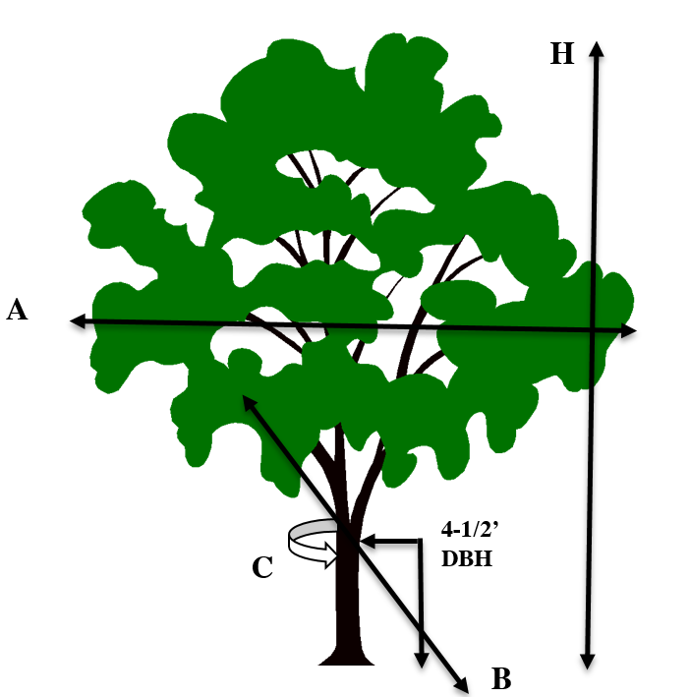

- (C) Circumference of the trunk at breast height (4-1/2 feet above the ground) in feet and inches. If there is a fork at this point, measure the smallest circumference below the fork. If it branches below 4-1/2 feet, measure the largest fork above the branching.

- (H) Height in feet, from the base to the topmost twig of the tree.

- (A & B) One quarter of the average Crown Spread in feet. The crown spread should be measured in two directions, perpendicular to each other, at the widest portion and the narrowest. The average of the two measurements is taken as the average crown spread.

The total of these three rounded figures gives a single figure denoting the score. In case of a tie, the tree with the largest trunk circumference becomes the winner. Trees will not be re-measured until five years have passed.
CHAMPION TREE NOMINATION FORM

Common Tree Name: _____________________________ Date Nominated: ______________
Genus and species (if known): ___________________________________________________

Tree Location: ___________________________ or GPS Reading: ______________________

or Section: _________ Twp: _________ R: __________ County ___________________

Tree Health Condition (circle one): Excellent Good Fair Poor

Estimated Circumference: ___ ft. ___ in. (at 4-1/2 ft. from the ground) Height: ____ ft.

Crown Spread: A ____ + B ____ = ______ total feet divided by 2 = the average of ____

FOR ND FOREST SERVICE USE ONLY Date officially measured: _________

Circumference in inches______ + Height in feet _____ + ¼ of the Average Crown Spread in
feet ______ = Total Cumulative Points ________ Measured by: ______________________

Please include a photo or e-mail a digital jpg to: beth.hill@ndsu.edu

If this is a champion, as the owner my signature below authorizes the release of my name, the tree and its location in a news release, on the ND Forest Service website and in the public “Register.”

Signature of Tree Owner: ______________________________________________________

Print Name of Tree Owner: ______________________________________________________
Address: ___________________________________________________________
City/State/Zip: _______________________________________________________
Telephone: ____________________ Email: _______________________________

Nominator of Tree: ___________________________________________________________
Address: ___________________________________________________________
City/State/Zip: _______________________________________________________
Telephone: ____________________ Email: _______________________________

MAIL THIS FORM TO: Beth Hill NDSU-North Dakota Forest Service
916 E Interstate Ave, Suite 4
Bismarck, ND 58503

Or email to: beth.hill@ndsu.edu Questions? Call Beth at (701) 220-5986
Deadline is December 31 of each year.

