# 

2019 Teacher's Guide

**www.keep-nd-clean.org**

## **Keep North Dakota Clean (KNDC)** is celebrating their **51st** year as the largest and longest-running artwork contest in the state! KNDCis proud to partnerwith **Newman Outdoor Advertising** to motivate youth and adults to take action in their daily lives to protect the environment. Collective environmental actions—even small steps—when taken together can create large-scale impacts. Help keep North Dakota clean and healthy for the people and animals that live and visit here. The artwork contest is for students in grades PreK-12 and students with special abilities. Participants create artwork that reflects their knowledge about the responsibility we all have to keep our state and water clean, reduce litter and waste, recycle, plant trees, prevent wildfires, create wildlife habitat, and use all of our natural resources wisely.

## First place winners receive a cash award of $100, a certificate, a gold medallion, and PreK-8 grade students have their artwork made into billboards by **Newman Outdoor Advertising** and placed near their hometowns. Second place winners receive a cash award of $75, a certificate, and silver medallion; third place winners receive a cash award of $50, a certificate, and a bronze medallion. All state winners, their immediate families, and teachers, will be invited to an awards ceremony and luncheon on Friday, April 26, 2019, at the National Energy Center of Excellence at Bismarck State College in Bismarck, ND.

## 

**Artwork Contest Rules for Grades PreK-8**

The best artwork design for a billboard is bright, bold, and simple with dark lettering. Keep in mind, people can only read and understand about six words as they drive by at highway speeds. Make a colored photocopy for the student to keep prior to mailing their artwork to KNDC, because **originals will NOT be returned**.

* All entries **MUST** be received by or postmarked no later than Friday, **March 15, 2019.**
* All artwork **MUST** be onwhite **8.5 x 14 inch paper** in ***landscape*** format. Other sizes are disqualified.

This size is necessary so Newman Signs can scan the winning artwork to fit on a billboard.

* All entries **MUST** have a completed “Entry Form” taped to the back of the artwork.
* All entries **MUST** have the student’s first and last name printed legibly on the BACK of the artwork in the lower right-hand corner. Don’t use heavy ink that may bleed through or show in the front.
* The theme **MUST** be on each entry and spelled correctly or will be disqualified. Special abilities students may use their theme or their grade theme. See page 2 for the themes for each grade.
* Entries **MUST** be reproducible and will be judged on readability at ten feet, originality, and neatness.
* All entries **MUST** be original artwork created by the student. Computer-generated art or printing, commercial glue-on letters, or copyright items (music, Disney characters, etc.) will **NOT** be accepted.
* All entries **MUST** lay flat. They should **NOT** be folded, matted, mounted, laminated, or framed. They may be rolled and put into a tube and mailed, if necessary.
* Artwork may be done in marker, crayon, watercolor, ink, acrylic, or tempera paint. Colored pencils and oil pastels are **NOT** acceptable. Bright, bold, and dark simple artwork shows up the best on billboards.
* Each school may submit only **one winner per classroom.** For example, if a school has three 4th grade classrooms, each teacher can submit the best poster from their classroom.

##### Artwork Themes

STUDENTS with SPECIAL ABILITIES PreK-8 Theme: 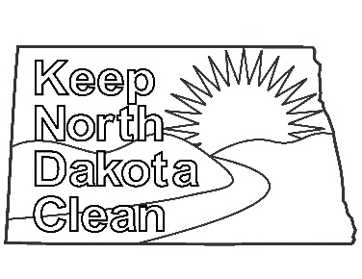**Keep North Dakota Clean – Students with special abilities may select this theme OR the appropriate grade level theme.** Downloaded the coloring sheet off the KNDC website at www.keep-nd-clean.org. Questions call Pam Wenger (701) 328-4787 or Sara Helm (701) 328-2540. *SPONSOR*: ND Department of Transportation

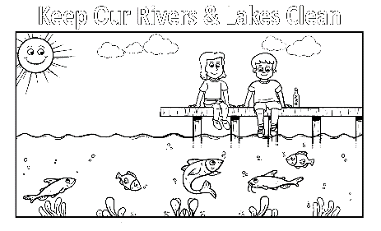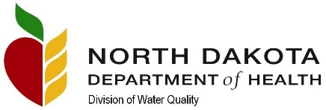Pre-SCHOOL/KINDERGARTEN Theme: **Keep Our Rivers & Lakes Clean -** Many of ND’s cities and towns are located near rivers and lakes, which serve as sources of drinking water and recreation. The color sheet must be downloaded off the KNDC website at www.keep-nd-clean.org. Questions call Jim Collins, Jr. (701) 328-5161. *SPONSOR*: ND Department of Health-Division of Water Quality.

GRADE 1 Theme: **Keep ND Highways Clean** –ND highways are littered with trash every year. Please help keep our highways clean and safe. Create a poster depicting a car traveling on a clean highway or someone putting trash in a can at a rest area. Questions call Pam Wenger (701) 328-4787 or Sara Helm (701) 328-2540. *SPONSOR*: ND Department of Transportation.

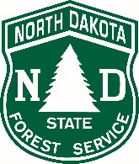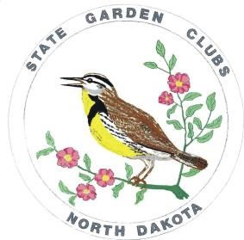

GRADE 2 Theme: **Happy 75th Smokey!** - Artwork must include a photo of Smokey Bear celebrating his 75th birthday in a forest. Smokey promotes the prevention of human-caused wildfires. Questions call Ryan Melin (701) 220-1475 or Les Westgard (701) 371-8388. *SPONSORS*: ND Forest Service-Fire Management and ND State Garden Clubs.

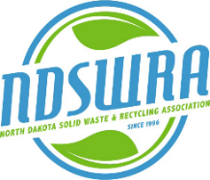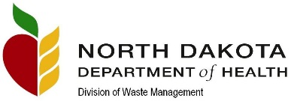GRADE 3 Theme: **Reduce, Reuse, Recycle -** How can we help reduce the waste we make every day? When we reduce, reuse, and recycle, we can save our earth’s resources. Questions call Diana Trussell (701) 328-5164; Chris **Kreger** (701) 330-4391; or Galen Bren (701) 355-1783. *SPONSORS*: ND Department of Health-Division of Waste Management, ND Solid Waste and Recycling Association, and City of Bismarck/Recycling.

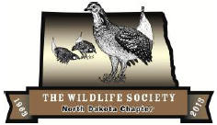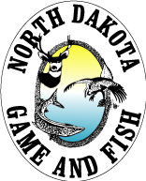GRADE 4 Theme: **Habitat—Homes for Wildlife -** North Dakota has five major habitats. They are prairie, badlands, wetlands, riparian areas and woodlands. Each of these habitats is important to wildlife of North Dakota and each is home to different species of wildlife and plants. For questions on these habitats or the contest, contact Sherry Niesar at (701) 527-3714 or Kristine Askerooth (701) 724-3598. *SPONSORS*: ND Game and Fish Department and ND Chapter of the Wildlife Society.

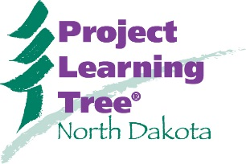GRADE 5 Theme: **Plant a Tree Today! -** Students will create artwork that reflects their understanding of the important role trees play in communities and the countryside. They provide beauty; food; habitat for wildlife; protect water and soil; produce oxygen; improve air quality; and provide recreation opportunities. Questions call Loretta Forsberg (701) 228-5422. *SPONSOR*: ND Forest Service-Project Learning Tree.

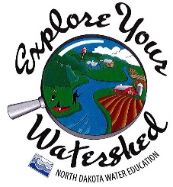GRADE 6 Theme: **Help Prevent Runoff Pollution** - When it rains, pollutants from many different human activities that are on the land in a watershed, whether urban or rural, are carried over the land directly to a water body, enter an underground aquifer, or are carried through storm sewers to a water body. People can prevent or reduce runoff pollution. Questions call Tina Harding (701) 328-4833. *SPONSOR*: ND State Water Commission-Project WET and ND Water Education.

GRADE 7 Theme: **Keep Our Beaches Clean** - From local lakes to Lake Sakakawea and the Missouri River, keeping our beaches clean not only makes them look better but keeps them safer for others. Questions call Tina Harding (701) 328-4833 *SPONSOR*: ND State Water Commission.



GRADE 8 Theme: **Explore a Greener North Dakota -** When Lewis and Clark explored this area over 200 years ago, they found an unspoiled environment. Today, we can help ensure a “greener” North Dakota for future generations by growing our recycling efforts, preserving our natural spaces, and using our natural resources responsibly. Questions call Dana Morrison (701) 462-8535. *SPONSOR*: The North Dakota Parks and Recreation Department.

*KNDC, Inc., under Title VI of the Civil Rights Act of 1964, ensures that no person in the United States shall, on the grounds of race, color, religion, or national origin, be excluded from participation in, be denied the benefits of, or be otherwise subjected to discrimination, including sex, age, disability, low-income, or LEP discrimination, under any program or activity for which the recipient receives federal financial assistance.*

The promotion of and participation in the poster contest shall not exclude anyone from participating in, denying benefit of, or otherwise subject anyone to discrimination on the basis of race, sex, national origin, age, religion or disability.

This KNDC promotional flyer is available in an alternative format by calling (701) 328-5161.

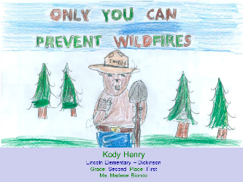2018 Artwork Winners

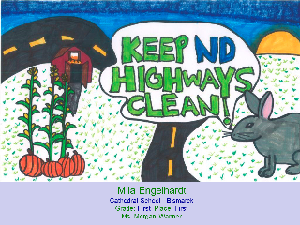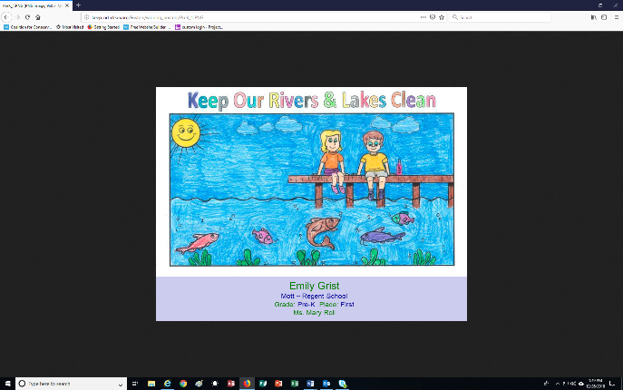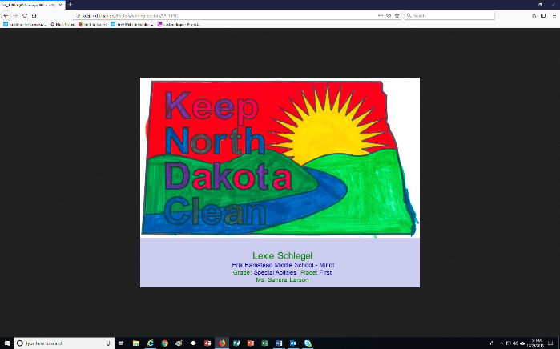

Pre-K

Emily – Mott / Regent

Special Abilities

Lexie - Minot

First Grade

Mila - Bismarck

Second Grade

Kody - Dickinson

Third Grade

Samantha - Bismarck

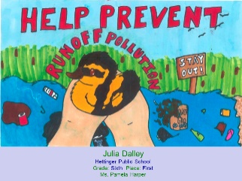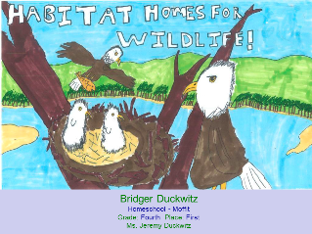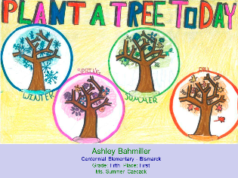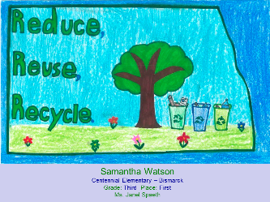

Fourth Grade

Bridger - Moffit

Sixth Grade

Karla - Garrison

Fifth Grade

Alex Bismarck

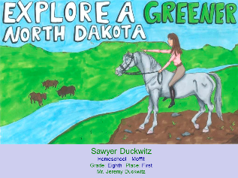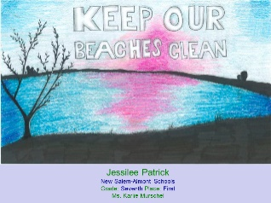

Eighth Grade

Sawyer - Moffit

Seven Grade

Jessilee – New Salem / Almont

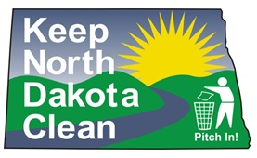

High School Grades 9-12

Artwork Contest

Keep North Dakota Clean Inc. and the North Dakota Parks and Recreation Department are sponsoring an artwork contest to promote keeping North Dakota trails clean by showcasing the creative talents of students in grades 9-12.

**www.keep-nd-clean.org**

**High School (Grades 9-12) Contest Rules**

* The entry theme must convey the message and include the theme “Keep North Dakota’s Trails Clean.”
* Entry MUST be an original student (in grades 9-12) created artwork.
* All artwork **MUST** be onwhite **8.5 x 14 inch paper** in ***landscape*** format. Other sizes are disqualified.
* **Any North Dakota student in grades 9-12 interested in participating may submit one entry.** There is no requirement for a school to send in only one winning entry per school.
* All entries **MUST** lay flat. They should **NOT** be folded, matted, mounted, laminated, or framed. They may be rolled and put into a tube and mailed, if necessary.
* Artwork may be done in marker, crayon, watercolor, ink, acrylic, or tempera paint. Colored pencils and oil pastels are **NOT** acceptable. Bright, bold, and dark simple artwork shows up the best.
* All entries **MUST** have the student’s first and last name printed legibly on the BACK of the artwork in the lower right-hand corner. Don’t use heavy ink that may bleed through or show in the front.
* There must be a completed Entry Form accompanying the artwork.
* All submitted files will become the property of KNDC for educational and promotional purposes **ONLY and will NOT be returned**.
* Entries must be mailed by **March 15, 2019**, to: **KNDC Artwork Contest, PO Box 1138, Bismarck ND 58502-1138.**

***The top three state winners,their immediate families, and teachers*** will be invited to an awards ceremony during Earth Day week on **Friday, April 26, 2019,** at the National Energy Center of Excellence at Bismarck State College in Bismarck, ND. After the awards ceremony, a luncheon will be served. The ***First Place Winner*** will receive a cash award of $100, a certificate, and a gold medallion. The ***Second Place Winner*** will receive a $75 cash award, a certificate, and a silver medallion. The ***Third Place Winner*** will receive a cash award of $50, a certificate, and a bronze medallion.

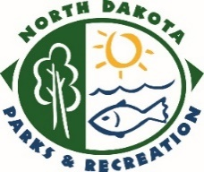

**Questions** contact: Dana Morrison (701) 462-8535 or [dmmorrison@nd.gov](mailto:dmmorrison@nd.gov)

**2019 Grade Sponsors**

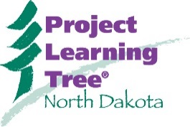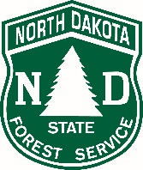



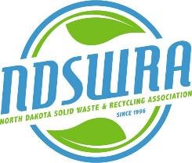****

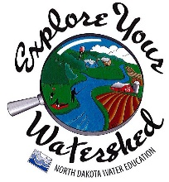



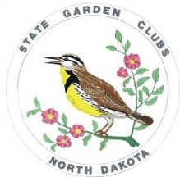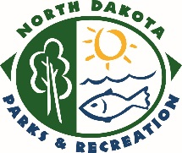 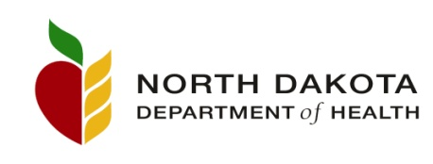

***Thank you to our 2018 Financial Sponsors***

**PLATINUM ($750+)**

McQuade Charity Softball Tournament

Newman Outdoor Advertising

ND Department of Health

Division of Waste Management

Division of Water Quality

ND Department of Transportation

ND Forest Service

Fire Management

Project Learning Tree

ND Game and Fish Department

ND Parks and Recreation Department

Lewis and Clark Interpretive Center

ND State Water Commission

Project WET

ND Water Education

Diana Trussell

**GOLD ($500+)**

Little Caesar’s Pizza

ND Department of Public Instruction



**SILVER ($250+)**

Dr. Marcus and Margaret Fiechtner

ND Chapter of the Wildlife Society

ND Solid Waste and Recycling Association

Waste Management Inc.

**BRONZE (under $250)**

Barr Engineering

Capital City Restaurant Supply

City of Bismarck-Recycling

Dakota Promotions and Printing

Jean Monroe

ND Association of Soil Conservation Districts

ND State Garden Clubs

ND Natural Resources Trust

Reservation Telephone Cooperative

US Geological Survey

The promotion of and participation in the poster contest shall not exclude anyone from participating in, denying benefit of, or otherwise subject anyone to discrimination on the basis of race, sex, national origin, age, religion or disability.

**Interested in becoming a sponsor? Contact KNDC vice-president, Diana Trussell at** [**dtrussell@nd.gov**](mailto:dtrussell@nd.gov) **/ (701) 328-5164.**

2019 KNDC Entry Form

**Grades PreK-8 MUST tape this form to the back of each artwork.**

**Grades 9-12 MUST tape this form to the back of each artwork.**

All entries become the property of KNDC and ***will not be returned*.**

**Please “print” clearly and complete all boxes in this form.**

|  |  |
| --- | --- |
| **Please circle the student’s grade below.** | |
| **Grade (***circle one***):**  Student with Special Abilities Pre-K 1st 2nd 3rd 4th 5th 6th 7th 8th HS (9th-12th) | |
| **County your school is in (**i.e**.** Ward or Burleigh**): __________________________________** | **How many students in your *classroom* participated in the contest this year? ________** |
| **Photo permission:** I consent to the use of any photographs taken of me at the awards ceremony to be used by KNDC Inc. strictly for promotional use of the contest. I understand all artwork becomes the property of KNDC and will **NOT be returned to the student, parents or school.** Every entry line must be completed.  **Student’s signature: ______________________________ Parent’s signature:____________________________**  **Print student’s name: ______________________________ Print parent’s name: ____________________________**  **Circle one:** Male or Female **Date: __________**  **Teacher’s signature: ______________________________**  **Print teacher’s name: ______________________________ Date: __________** | |
| **Print student’s home mailing address below**:    Address:___________________________________  City, State & Zip: ___________________________ | **Student’s home telephone**: |
| **Parent’s cell or work telephone or email**: |

|  |  |
| --- | --- |
| **Print name of student’s school:** | **School telephone:** |
| **Print school’s mailing address below:**    Address:___________________________________  City, State & Zip:____________________________ | **Teacher’s email address at school:**  **Teacher’s cell or work telephone:** |
| **Grades PreK-8** and **Grades 9-12** postmark by **March 15, 2019**, mail to:  **KNDC ARTWORK CONTEST**  **PO BOX 1138**  **BISMARCK ND 58502-1138** | |