Red River Valley Tile Drainage
Water Quality Assessment
Phase I Final Report

October 2010

Roxanne Johnson
Water Quality Associate
Ag and Biosystems Engineering Department
North Dakota State University
Fargo, ND

Abstract
Following many years of increased precipitation in eastern North Dakota, the practice of subsurface drainage of agricultural land has rapidly increased. Farmers install tile drains to allow earlier access to fields, to remove wet areas that interrupt field traffic patterns, and to decrease salinization; thus increasing crop yield and profit. While many states have used subsurface drainage, eastern North Dakota contrasts with others because of high saline soils and subsequent increased soluble salts in the tile effluent. Concerns also include possible impacts of this water eventually flowing into the Red River of the North and Lake Winnipeg in Manitoba, Canada. This monitoring project was developed to gather base-line water quality data including but not exclusive of soluble salts, phosphorus and nitrogen in effluent from tile drains. Eighteen tile drains were sampled each week for thirty-two weeks in 2008 by the watershed coordinator at Cass County Soil Conservation District and an NDSU Extension water quality associate. Cooperators provided information on cropping and fertilizer history, tile maps and soil samples when available. The maximum limit allowed based on the Standards of Water Quality for the State of North Dakota were exceeded for sulfates (at thirteen sites), chloride and boron (at two sites), nitrate (N) (at eighteen sites) and barium (at eighteen sites). The mean for trace metals, selenium (at seven sites) and aluminum (at one site), were found to be above the aquatic threshold as determined by the North Dakota Department of Health for streams in North Dakota. Electrical conductivity at the lift stations were often quadruple the levels at gravity flowed outlets. This may be due to the geographical lay of the land and its history of water naturally draining into that area, depositing more minerals than in other subsurface drain locations.
Goals
Summarization of major goals:
The goals of this project are:
1) Determine the effect tile drainage has on water quality in the Red River Basin;
2) Provide baseline data needed for a more intensive study to be completed as Phase II.

Objectives and Tasks
Objective 1: Determine the effect tile drainage has on water quality in tributaries of the Red River Bain located in Cass County and southern Traill County.
Task 1: On-site collection and analysis of water for pH, Specific Conductivity (EC), and temperature. Samples will be sent to a laboratory for a general chemistry panel and pictures will be taken of bottles for turbidity.
Outcomes: With the assistance of the Cass County Soil Conservation District watershed coordinator, samples were taken at eighteen sites in Cass and southern Traill Counties (Elm, Maple and Rush River watersheds) for a period of 32 weeks in 2008. All samples were tested for pH, EC, and temperature using an Oakton Model 35630-62. The meter is owned by the Cass County Soil Conservation District and calibrated by the district watershed coordinator prior to use. Temperature was helpful in determining if flow was captured in submerged outlets as the tile water was cooler than the stream water. Initial observations of increased EC measurements at the lift stations (2) indicated higher mineral loading.

Objective 2: NDSU Water Quality Specialists will analyze the results which will be used as baseline data for Phase II monitoring.
Outcomes: This project will give guidance to a more intense Phase II monitoring project. Phase I results showed high levels of sulfates at thirteen of eighteen sites, 2 sites with high chloride or boron and all sites showed nitrate levels over the standard of quality for waters of the state standard (1mg/L). Trace metals, selenium and aluminum, were found to be over the aquatic threshold.

Phase I Map
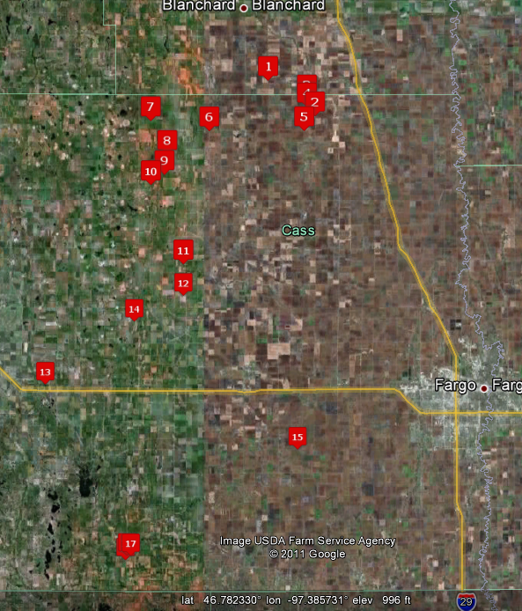
All sites in Phase I.
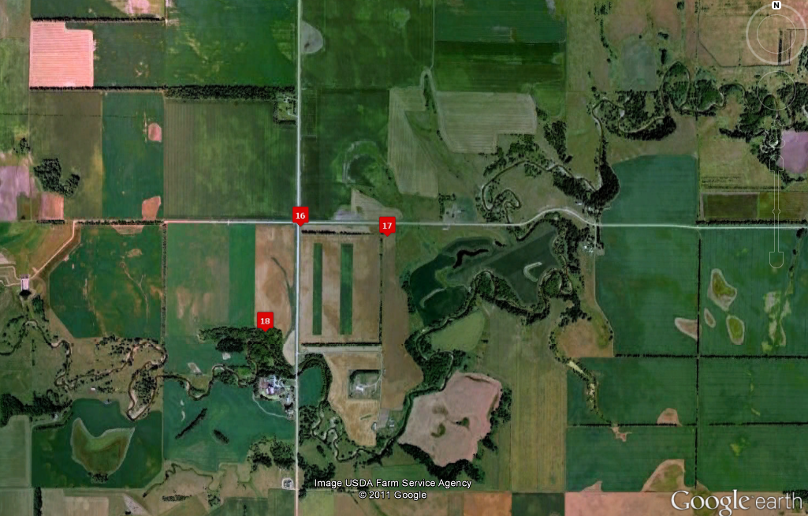
Detail of north edge.
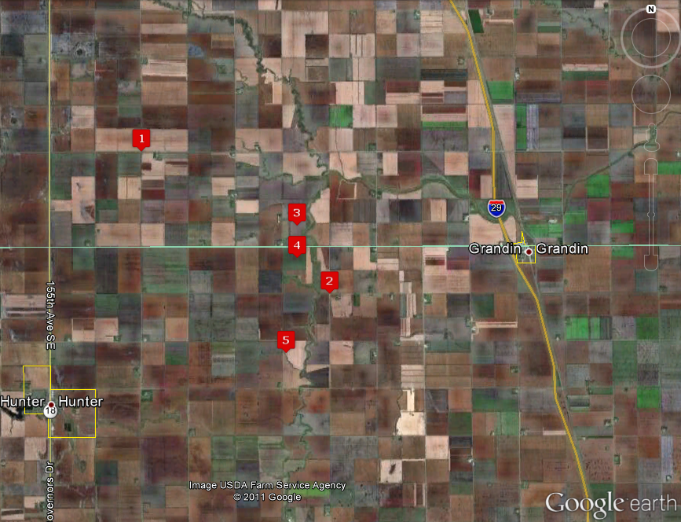
Detail of south edge.

The maps featured above show the eighteen sites that were sampled in Phase I. The watersheds included the Elm River watershed, Rush River watershed and the Maple River watershed. The legend below includes the GPS locations for each site.
Legend
SITE | STORET | DLAT | DLONG |  | SITE | STORET | DLAT | DLONG
1 | 385427 | 47.2678378 | -97.1941469 |  | 10 | 385438 | 47.1435998 | -97.3876838
2 | 385428 | 47.271557 | -97.1762877 |  | 11 | 385439 | 47.0426488 | -97.3490119
3 | 385429 | 47.2278968 | -97.0914488 |  | 12 | 385440 | 47.006681 | -97.329125
4 | 385430 | 47.248764 | -97.106669 |  | * | 385441 | 47.0141758 | -97.417248
5 | 385431 | 47.2388058 | -97.1111861 |  | 13 | 385442 | 46.8975428 | -97.57693
6 | 385432 | 47.209878 | -97.2823477 |  | 14 | 385443 | 46.9749188 | -97.4825008
7 | 385433 | 47.2221418 | -97.3881388 |  | 15 | 385444 | 46.8179458 | -97.1246397
* | 385434 |  |  |  | 16 | 385445 | .46.6878188 | -97.4300469
8 | 385436 | 47.1807888 | -97.3581938 |  | 17 | 385446 | 46.6874728 | -97.4232047
9 | 385437 | 47.15612 | -97.363195 |  | 18 | 385454 | 46.682143 | -97.4328388
*Site dropped

Results
The purpose of this study is to determine baseline water quality from tile drains in Cass County, North Dakota. This project does not include flow measurements and therefore no total loading parameters. Water quality will be compared to previous water quality studies at streams and rivers within the watershed, national drinking water regulations, and North Dakota standards of quality for waters of the state. Future studies include a five-year project (Phase II at 8 sites across eastern North Dakota focusing on tile drain water quality from saline soils. Water quality and quantity will be assessed.
Trace metals of concern for this study include Aluminum (Al), Arsenic (As), Barium (Ba), Boron (B), Copper (Cu), Lead (Pb), Nickel (Ni), Selenium (Se), and Zinc (Zn). Copper, lead, nickel and zinc were calculated using a hardness factor of 400 mg/L CaC0₃ to determine if the results were below the aquatic life values required by North Dakota Standards of Quality for Waters of the State, Chapter 33-16-02.1. It should be noted that four sites (4, 5, 7 and 15) outlet directly into rivers with the remaining sites depositing into a ditch. There has been extensive research on water quality exiting irrigated tiled fields in California; there has been little research on water quality, specifically metals, coming from tiled fields that are dependent on annual rainfall. However, when trace metals exceed the threshold, impairments to the ecosystem may occur. High levels may affect fish populations by altering food availability, may increase fish mortality, reduce fish reproduction, and other ecological damage may occur which may not support aquatic life.
The maximum limit allowed based on the Standards of Water Quality for the State of North Dakota was exceeded (mean) for sulfates (at thirteen sites), chloride and boron (at two sites), nitrate (N) (at eighteen sites) and barium (at eighteen sites). The mean for trace metals, selenium (at seven sites) and aluminum (at one site), were found to be above the aquatic threshold as determined by the North Dakota Department of Health for streams in North Dakota.
The EPA’s Maximum Contaminant Level (MCL) for primary and secondary drinking water standards was exceeded by aluminum at 4 sites, arsenic at 3 sites, selenium at 4 sites, copper at 14 sites, manganese at 1 site, nitrate nitrogen at 12 sites, and sulfates at 14 sites. This parameter was included to give comparison references only. This water is not consumed by humans.
Metal and nutrient graphs are included to depict the information stated above and will also include comments pertinent to the parameter.

Aluminum

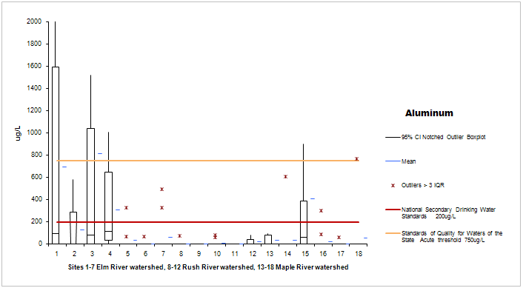
Aluminum was reported over the state aquatic standard and the standards of quality for waters of the state (750ug/L) in nine of two-hundred and forty eight samples (3.6%). Samples ranged from non-detectible to 4740ug/L at five sites. Two sites flow directly into a river and could result in impairment to aquatic life. Four sites had mean values over the national secondary drinking water standard of 200ug/L.

Arsenic

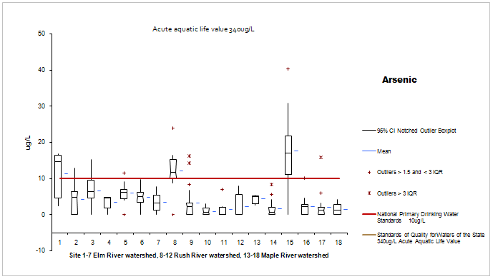

The primary drinking water standard for arsenic is 10 micrograms per liter. Levels over the MCL of 10ug/L were found at 7 sites. Twenty-four percent of the one hundred and seventy-six samples found arsenic over the 10ug/L standard. Site 1had 3 samples, with 2 over 10ug/L. Site 2 had 2 samples over the 10ug/L standard and 7 of 17 samples non-detectible. Site 3 had 8 samples with 2 over the limit and 3 over 8ug/L. It should be noted that these 3 sites are all in the same area of southern Traill and northern Cass counties. Site 8 had 83% over the limit with 3 over 8.8ug/L. Site 9 had 2 over the limit or 9.5%. Site 15 was over the limit on 87% of the samples. Of the 2 samples that were under the limit, one was at 9.2ug/L. Site 17 had 1 of 17 samples exceeding the limit at 15.8ug//L.
The acute aquatic life level should be under 340ug/L and all were found to be under this threshold.

Barium

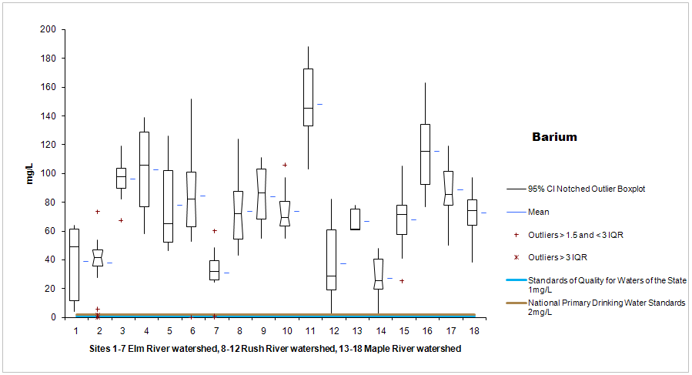

Barium was found over the threshold for surface waters and drinking water at all sites. The EPA lists an increase in blood pressure as a side effect of long-term exposure above the MCL for drinking water. There is not an aquatic threshold for barium.

Boron

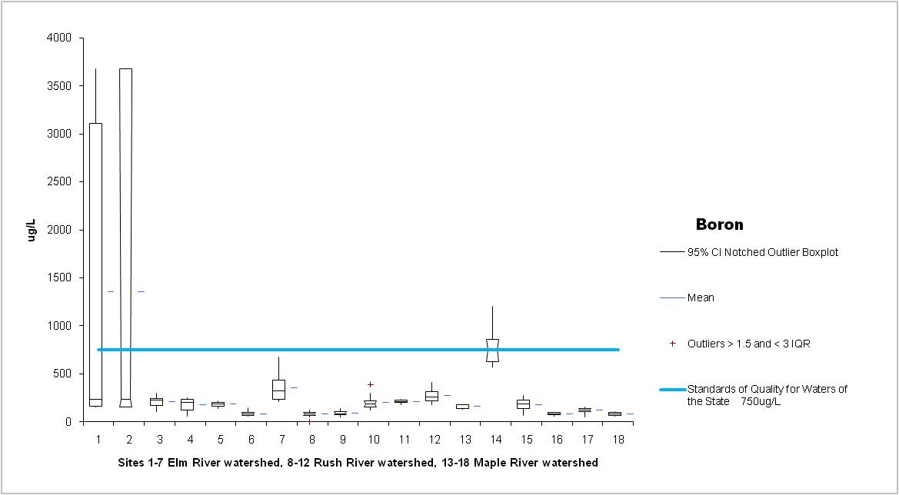
Surface water quality standards are set at 750ugL for boron. The mean for sites 1 and 2 exceeded this value. Site 1 was sampled three times and may not be representative of the effluent. Site 2 is a lift station in and within one-half mile of Site 1. This area’s soils may be naturally high in boron. Both sites drain into the ditch.

Copper

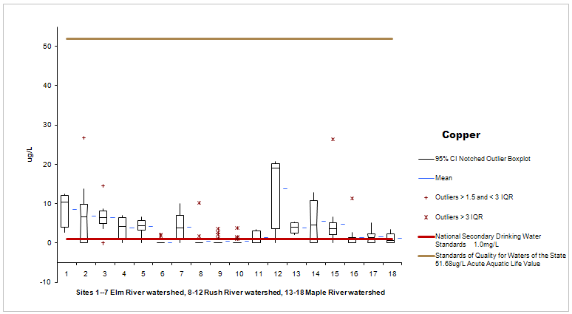
The calculated aquatic criterion continuous concentration (CMC) or acute exposure value for copper is 51.68u/L. If values are lower than this level there should be no unacceptable effects to aquatic organisms. This threshold is hardness dependent and based on a one-hour concentration; not exceeding the CMC value more than once every three years on average. The Phase I study found no samples to exceed the CMC threshold.
The mean values found secondary drinking water standards were exceeded at 14 of the sites, with ranges from 0 to 26.7ug/L.

Lead

Lead was not detected in any samples sent in for analysis.

Nickel

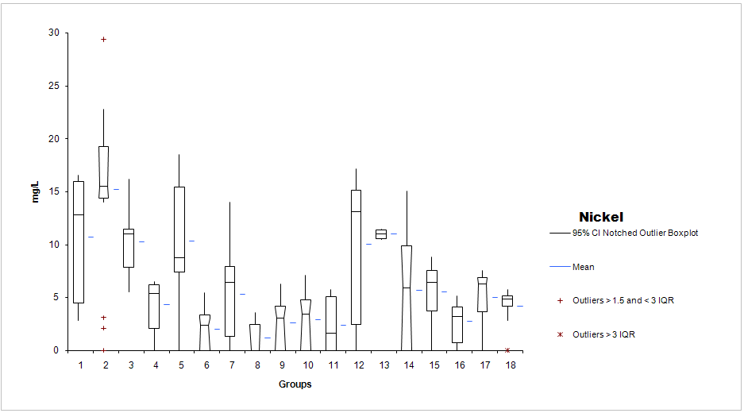

Nickel is hardness dependent. The calculated CMC for nickel is 1515.92u/L. All samples fell below this value.

Selenium

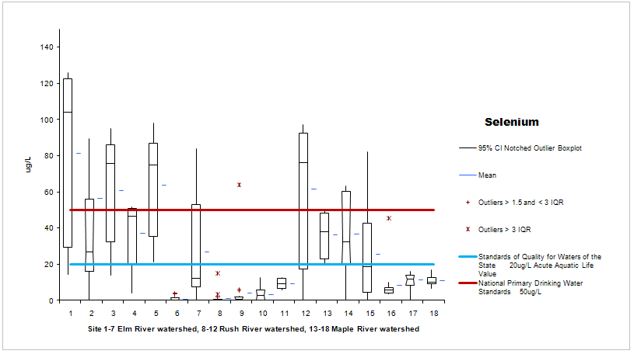

While selenium is an essential trace nutrient for animals, higher levels may cause reproductive failures, birth defects or death in livestock, wildlife and fish. It is known to naturally occur in the weathering process of marine shales.
Selenium was found at ten of the eighteen sites at levels higher than 20ug/L, the acute standard set by the state (blue line in graph). Seven sites recorded no detection throughout the season. Site 5 had detections in 100% of the samples (n12) ranging from 21ug/L to 97.8ug/L. This site was tiled a year prior to the study in predominately Fargo silty clay. The crop rotation over the last 3 years was soybean, corn, soybean, with no fertilizer used in 2008. It appears that if you have selenium detected, it is detectible throughout the year. Site 2 had 14 of 18 samples with very high selenium values; ranging from one non-detect and increasing to 261ug/L in November, 2008. The data indicates the level decreased from 89.2ug/L to 9.69ug/L between April 30, 2008 and June 23, when it spiked again to 54.7ug/L. Notes do not reflect a rain event at this time. Levels consistently fell from 54.7ug/L to the lower twenties and upper teens until November 13th when it spiked again following a .98 inch rain event. This site deposited into a river.
The mean exceeded the primary drinking water standard at five sites (red line in graph).

Zinc

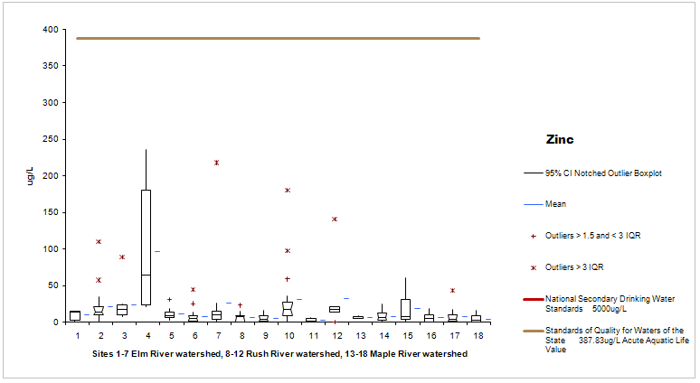

Zinc is hardness dependent and the calculated acute aquatic life level is 387.83ug/L. All samples fell below this value. All samples also fell below the secondary drinking water standard.

Sulfates

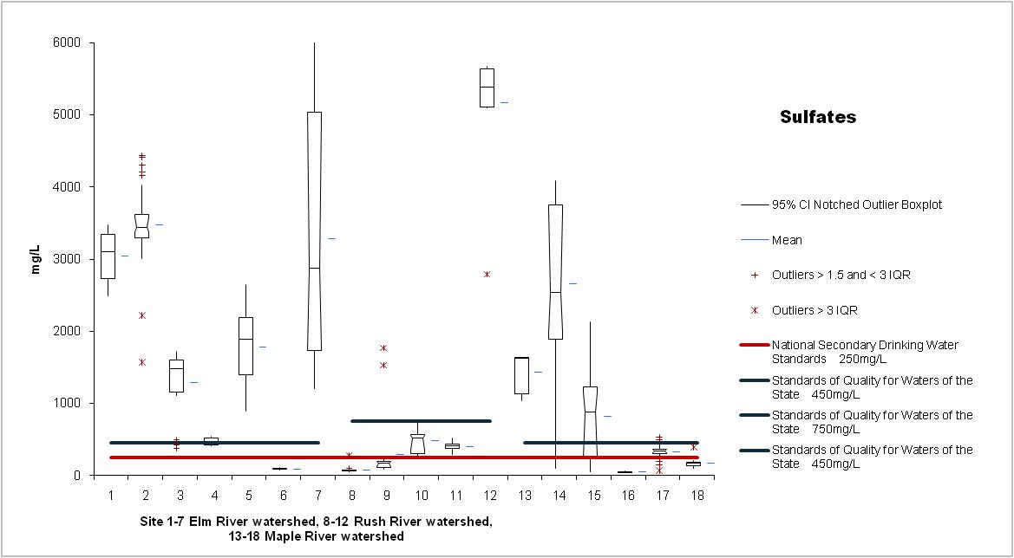

Sulfates were found over the secondary drinking water standard of 250mg/L at thirteen sites. Secondary standards are associated with the aesthetic quality of the water and although may not be pleasant to drink, will not cause health problems. Water high in sulfates usually requires further treatment for public use.
Standards of Quality for Waters of the State levels are dependent on the stream classification for sulfates. The Elm River watershed and the Maple River watershed are classified as Class II and have a threshold of 450mg/L. The Rush River watershed is a Class III and has a threshold of 750mg/L. All samples on the Elm River watershed were over the threshold of 450mg/L which may degrade public health and environmental resources. Only site 12 was over the threshold of 750mg/L in the Rush River watershed and three of the six sites exceeded the standard in the Maple River watershed.

Chloride

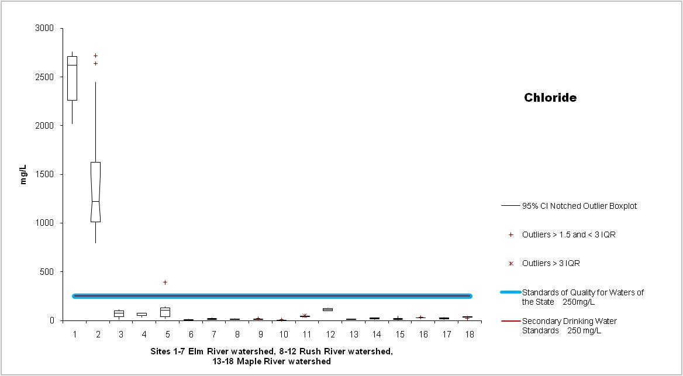

Sites 1 and 2 show levels above drinking water and surface water thresholds, while the other sites were well below. This may be due to excess salt levels in the soils in this area.

Manganese

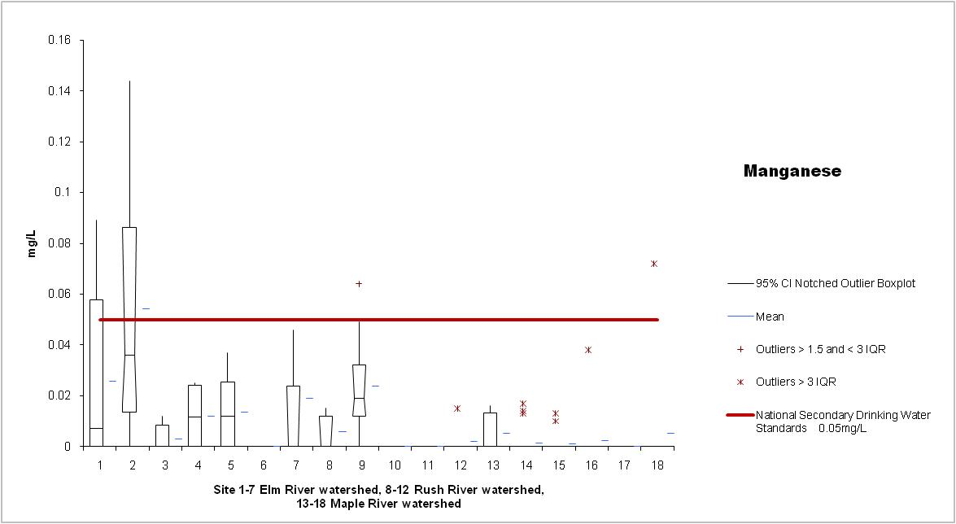
Site 2 was the only site with high levels of manganese. As you will recall sites 1 and 2 also had high levels of chloride which is typically observed in saline soils in this area.

Ammonia Nitrogen

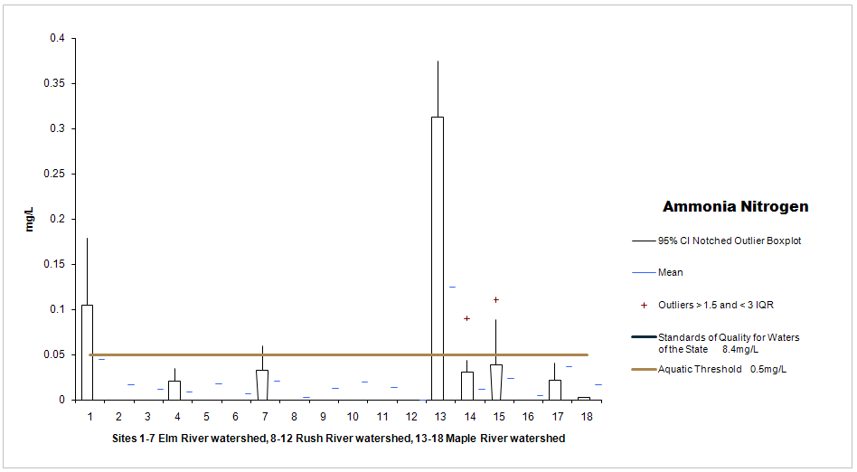

Ammonia nitrogen is believed to harm aquatic life if recommended levels are exceeded. Different species of fish can tolerate different levels of ammonia nitrogen, and plants are more tolerant than animals, and invertebrates are more tolerant than fish. Short periods of high levels of exposure can cause skin, gill and eye damage. Site 13 is the only site that reported high levels of ammonia nitrogen and it was one of three samples. The outlet at this site was constantly submerged and was influenced by ajoining fields.

Nitrate Nitrogen

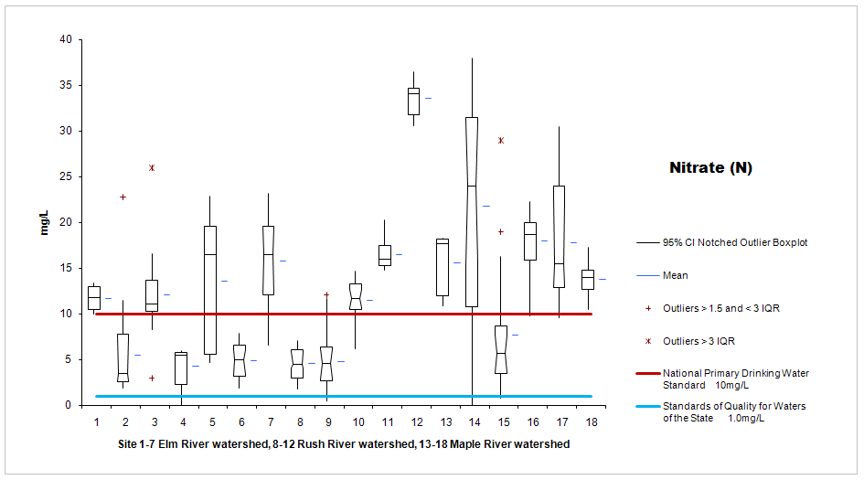

It is well known that nitrogen levels are higher in tile drain water than in surface water. Phase I confirmed higher than recommended levels of nitrate nitrogen were leaving the tile at levels higher than state standards of quality for waters of the state. Best management practices including split application of fertilizer can be suggested to the producers to reduce the amount of NO3(N) leaving the fields. Drinking water standards were exceeded at twelve sites. Although this water is not used for drinking purposes it may be reflected in increased costs to remove it at water treatment facilities.

Phosphorus

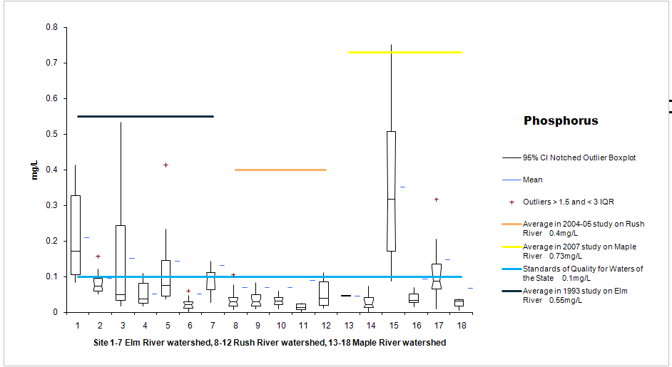

Phosphorus levels in past water quality studies on rivers within their respective watersheds were 0.4 to 0.6 mg/L higher than tile drain effluent levels. Most of the drain water quality was found to be below standards of quality for waters of the state, which is 0.1mg/L (13 of 18). Phosphorus typically adheres to soil particles and soil particles are not seen in drain effulent. Studies have shown decreased phosphorus levels in tile drains and less surface runoff (and therefore less phosphorus impacts to surface waters) when tile is installed.

pH
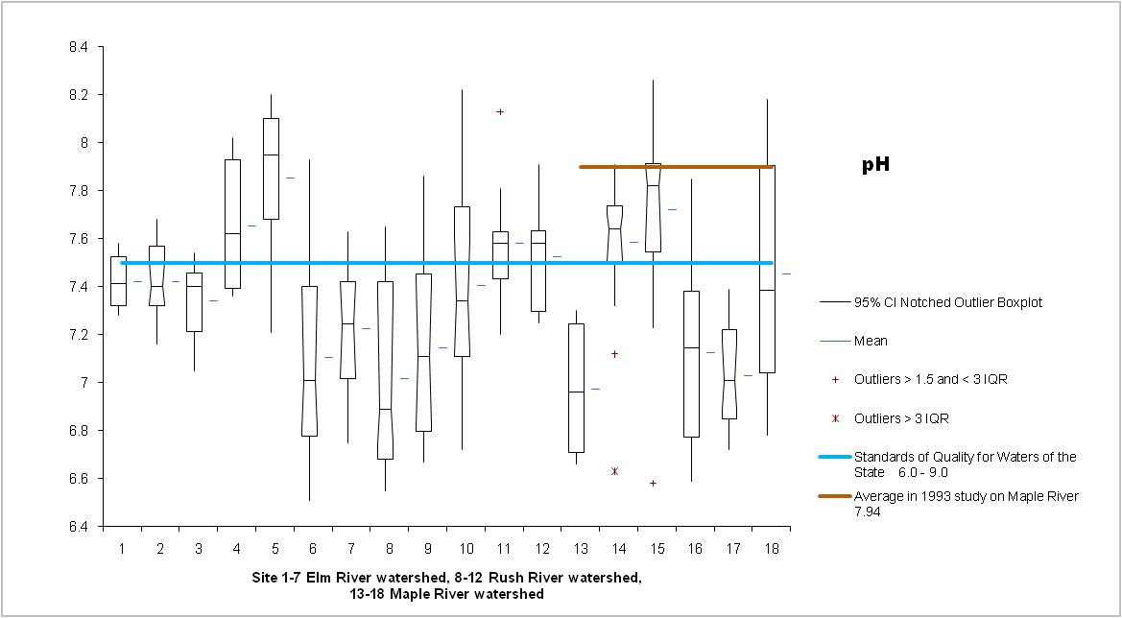
North Dakota standards of quality for waters of the state range from 6 to 9. pH levels in this monitoring project ranged from a low of 6.51 to a high of 8.26. A previous study on the Maple River in 1993 showed higher pH values than were seen in the tile drain effluent.

